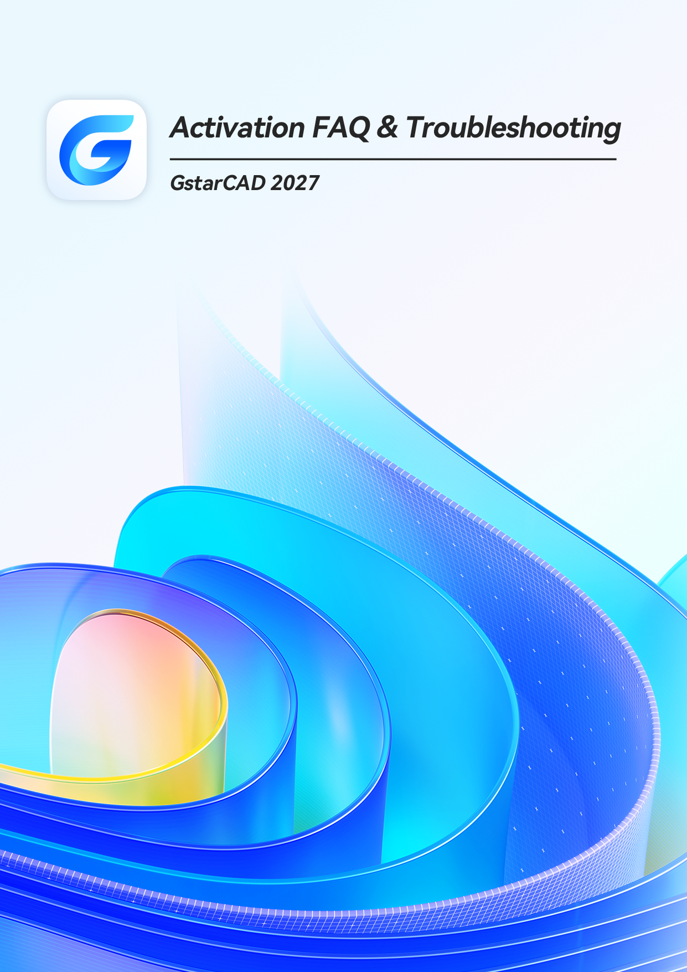
GstarCAD Activation FAQ & Troubleshooting

This document is a guide to help troubleshoot the common issues with activating GstarCAD.

Important:

Please make sure the computer has Internet access if you choose an activation
method that requires Internet connection.

Error Message: Cannot connect to server.

Cause:
The client cannot connect to the server.

Solution:

Please check the Internet connection and/or firewall settings, to make sure that
the client has proper access to the server and relevant interfaces.

Error Message：Number of network license nodes exceeds the limit.

Cause:
There is no node available in the license server because all nodes are being used.

Solution:

Please log out from other clients to make node available for the activation.

Error Message: Repeat importing response file or machine does not match.

Cause:
Repeated importing of the license response file, or the imported license response file does not match the current machine.

Solution:

Check whether the correct file has been imported, please find and import
the correct response file if a wrong file has been imported.

Error Message: Fail to install activation system service.

Cause:
The installation of system service required by activation has failed.

Solution:

Please verify that your system environment meets all the necessary requirements
and that you have permission to install the activation system service.

5.
Error Message: No permission to install activation system service.

Cause:
The activation system service cannot be installed due to insufficient permissions.

Solution:
Please verify that the client has the correct permissions to install the activation
system service.

6.
Error Message: Activation information does not contain specified version features.

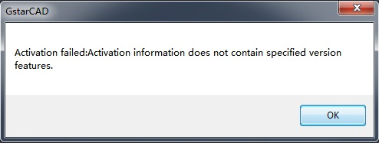
Cause:
The product or version you have selected in the activation page does not conform with the license key, for example, your license key is for GstarCAD Standard, but you have selected GstarCAD Professional in the activation page.

Solution:

Please select the product and version that match your license.

7.
Error Message: Unauthorized.

Cause:
Except for the known issues such as “no node available” “unable to connect to sever” “clock difference too large between client and server”, other issues related to authority are all considered unauthorized, which is unlikely to happen under normal circumstances.

Solution:

The client needs to provide developers with
%allusersprofile%/glmclient/log/glmc.log to identify the cause.

8.
Error Message: License has been activated with other dongle. Please unbind and return it first.

Cause:
The license has already been activated on a different USB dongle.

Solution:

Please unbind and return it first.

9.
Error Message: Cannot bind because of duplicated product type, version type, version number and language.

Cause:
The server records the license key and its corresponding dongle ID, if the dongle ID is different from the server records, such error message appears.

Solution:
To complete the binding, please replace it with a dongle that corresponds to the
license key.

10.
Error Message: Dongle ID has been blacklisted.

Cause:
The dongle ID has been blacklisted by the server.

Solution:

Please contact Gstarsoft Co., Ltd for a possible cause and solution.

11.
Error Message: Cannot bind because of duplicated product type, version type, version number and language.

Cause:
The license to bind is identical to the originally bound license (the same product type, version type, version number, and is in the same language).

Solution:

Please bind the license to another USB dongle, or get a new license to bind.

12.
Error Message: Encryption type does not match.

Cause:
The encryption (FLEXNET license, stand-alone dongle and network dongle) does not match the encryption type of the license. For example, the client has purchased a dongle license, but is trying to activate using FLEXNET.

Solution:

Please use encryption that matches the license.

13.
Error Message: License type does not match.

Cause:
The license type (perpetual, rental) does not match the encryption (FLEXNET license, stand-alone dongle and network dongle). For example, dongle can only bind perpetual license and cannot bind rental license.

Solution:

Please use encryption that matches the license.

14.
Error Message: Machine fingerprint has been blacklisted.

Cause:
The machine has been blacklisted by the server due to abnormal operation.

Solution:

Please contact your local reseller.

15.
Error Message: Inconsistent machine fingerprint.

Cause:
The fingerprint of the current machine does not match the server records.

Solutions:

Please check if you had replaced the machine or hardware and contact your local
reseller.

16.
Error Message: Session does not exist.

Cause:
The activation server cannot be accessed normally due to the system problem.

Solution:

Please open IE (Internet Explorer) > select Internet Options > select Security tab >
click Trusted sites

Add the two sites below to Trusted sites:
support.gstarcad.net
support2.gstarcad.net

Click OK to save the changes. Now you should be able to activate or return the
license.

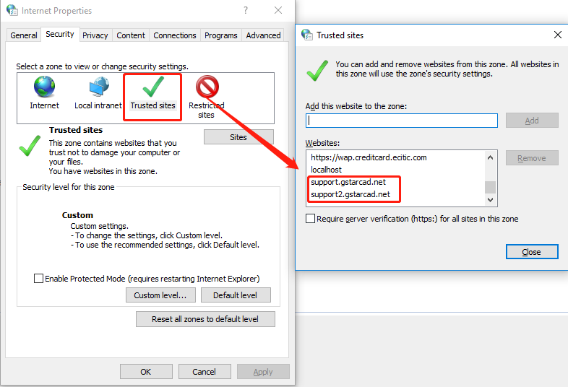

17.
Error Message: License has been activated on other machine. Please return it first.

Cause：
The license key has already been activated on another machine.

Solution:

Please return the license on that machine and then try again on this machine.

18.
Error Message: Cannot bind: license key already activated.

Cause:
The license key has already been activated and cannot bind.

Solution:

Please unbind the license key first before trying again, or use a different license
key to bind.
19.
Error Message: Cannot bind: license key already expired.

Cause:
Unable to bind because the license key has expired.

Solution:

Please contact your local reseller to purchase or apply for a new license key.

20.
Error Message: Cannot bind: license key has been reset.

Cause:
The license key has been reset by the server.

Solution:

Please contact your local reseller for a possible cause and solution.

