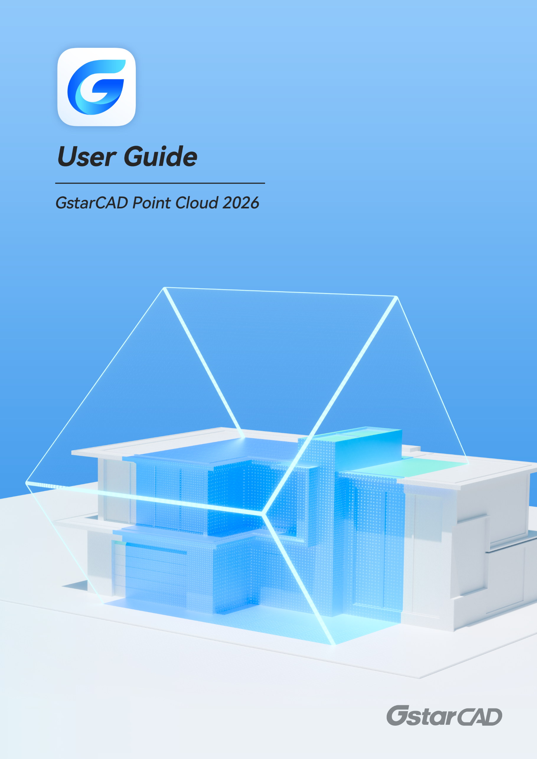

Contents
1. Undet Point Cloud Tab 3
1.1. Project Management 3
1.2. Display 11
1.3. Visualization 12
1.4. Clipping Box 14
1.5. Feature Extraction 16
1.6. Meshing 21
1.7. Draping 23
1.8. Image 24
1.9. Browser 26
1.10. Help 28
2. Undet Floor Plan Tab 29
2.1. Point Cloud 29
2.2. Section View 30
2.3. Floor View 34
2.4. Ceiling View 35
2.5. Axis 36
2.6. View Control 37
2.7. Draw 39
2.8. Modify 40
2.9. Layers 41
2.10. Tools 43
2.11. Help 44
3. Undet Indexer Project Creation Tutorial 45
3.1. Select project type based on your scan data set 45
3.2. Scan data file import 48
3.3. Grouping 49
3.4. Create Undet project 50
3.5. Created Undet project 55
4. Undet Brower with GstarCAD 56
4.1. Create an Undet Browser Project 56
4.2. Undet Browser features for GstarCAD 56


GstarCAD Point Cloud 2026
User Guide

For converting point clouds to CAD, we’re excited to introduce GstarCAD Point Cloud! Integrated with Undet Point Cloud plugin, this powerful solution offers a full suite of tools that allow you to seamlessly import and manage point cloud data directly in GstarCAD. With GstarCAD's comprehensive drafting features, you can create accurate 2D and 3D drawings from Point Cloud with great efficiency.
You can create point cloud projects seamlessly with data from any laser scanner or drone in Undet Indexer, then open, transform, and manage them directly in GstarCAD (Supported formats: *.E57, *.FLS, *.RCP/RCS, *.PTX, *.ZFS,*.LAS, *.LAZ, *.PTS, *.PLY, *.DP, *.FPR, *.LSPROJ, *.FWS, *.CL3, *.CLR, *.RSP, ASCII / NEZ (X,Y,Z/i/RGB) and custom ASCII / TXT file format import). GstarCAD Point Cloud also offers interactive editing and visualization capabilities, allowing users to view, analyze and navigate your digital data as a panoramic view in Undet Browser, speeding up the creation process.
This document includes guide for Undet Point Cloud and Undet Floor Plan in GstarCAD, as well as Undet Indexer project creation tutorial and Undet Browser features guide for GstarCAD.

Undet Point Cloud Tab
You can find various tools in the Undet Point Cloud tab, which splits into several logical tabs.

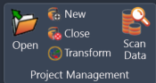
Project Management
- Open: Allows you to open an existing point cloud project.
- New: Opens the Undet Indexer to create a new point cloud project.
- Close: Closes the current point cloud project.
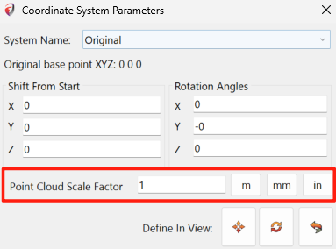
- Transform: Opens the Coordinate System Manager for moving/rotating point cloud.
  - The Point Cloud Scale function is designed to adjust the unit scale of point clouds, such as converting measurements between inches, millimeters, meters, or other units. This is particularly useful when the point cloud data and the drawing use different units of measurement.
This tool is essential for users who work with point cloud data in different measurement units, ensuring consistent and accurate scaling within the GstarCAD environment.
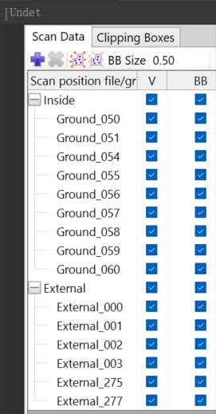
- Scan data: Opens the Scan Data toolbox.
  - Scan Data toolbox
 Add: creates a new scan position group.
 Remove: remove/ungroup selected scan position group.
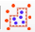 Entire project: groups scans of the full project (internal and external) by selecting internal scan position markers.
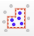 Inside Only: groups internal scans of the project by selecting internal scan position markers.
BB size: allows you to resize the scan position marker size (sphere).

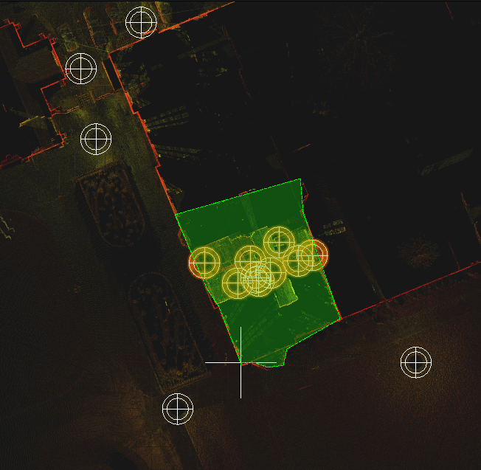
Steps to group scan positions:
- Make scan position markers visible by ticking BB in the Scan Data toolbox.
- Select Full project or Inside only grouping.
- Select all scan station markers for grouping.

After selecting all scan station markers, click ENTER twice to confirm the selection.
Pick a step-in scan height to group selected scan files into logical groups (external, Internal level 1, Internal level 2….) and press ENTER. After this, your scan stations will be grouped into logical groups.

    - Marker right mouse click menu
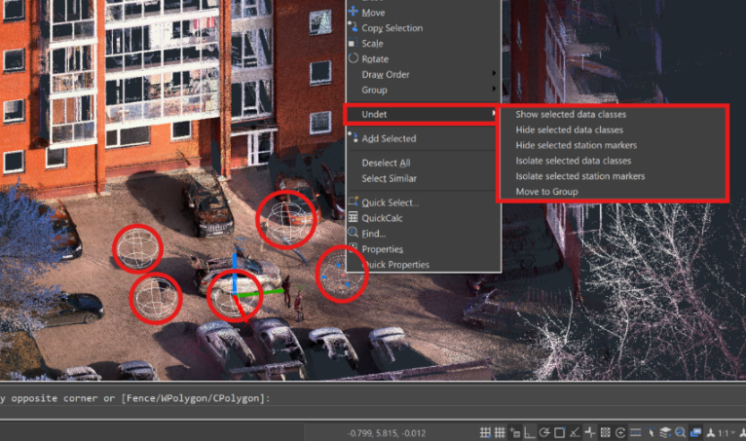
When Undet scan position markers are selected, you can access additional Undet functions by right-clicking, these options provide enhanced control and organization when working with Undet scan data classes.:
Show selected data classes: Display the selected scan data classes in your workspace.
Hide selected data classes: Conceal the selected scan data classes from view.
Hide selected station markers: Hide the markers associated with the selected scan data classes.
Isolate selected data classes: Focus exclusively on the selected scan data classes while hiding others.
Isolate selected station markers: Isolate only the markers related to the selected scan data classes.
Move to Group: Group the selected scan data classes for efficient management.

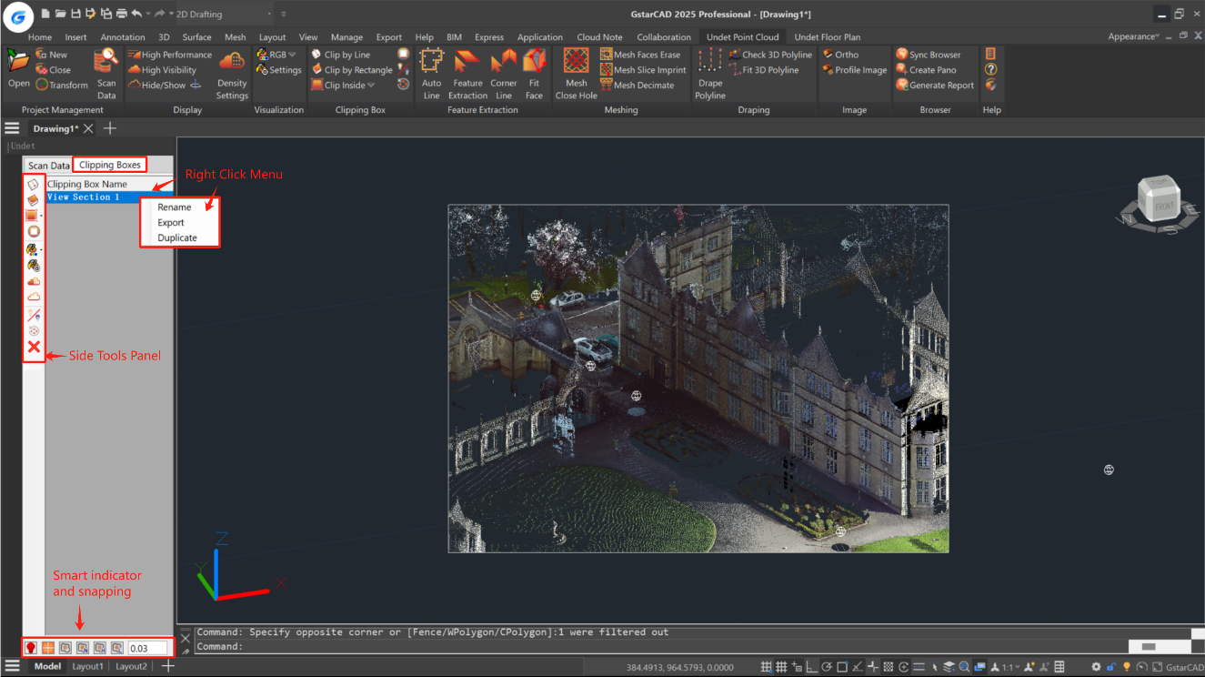
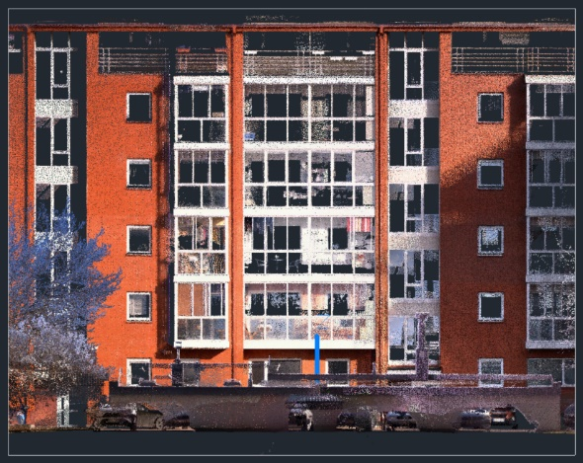
  - Clipping Boxes
    - Right Click menu
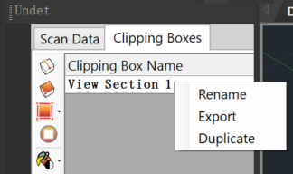
Right-click on Active View Section Actions:
Duplicate: Allows you to create a copy of the selected clipping box.
Export: Enables exporting the point cloud data visible within the boundaries of the selected clipping box as a new Undet project.
Rename: Allows you to change the name of a view section.

    - Side tools of Scan Data toolbox
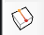 | Clip by Line | Creates a new clipping box defined by line and thickness:  Optional inputs:  T – Thickness: Choose thickness (default – 1 meter)  U – UCS: Create a new UCS based on your clipping box.  V – View: Create a new view based on your clipping box.  A – UCS and View: Create a new UCS and view based on your clipping box.
 | Clip by Rectangle | Creates a new clipping box defined by a rectangle.
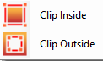 | Clip inside / outside | Defines polygon selection to clip the points inside or outside the selected area.
 | Deactivate | Deactives point cloud clipping.
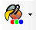 | Colouring by | Changes point cloud colouring mode.  (more details in the colouring section)
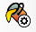 | Colouring Settings | Opens additional point cloud colouring settings.  (more details in the colouring section)
 | Density Settings | Opens Point Cloud density settings manager.
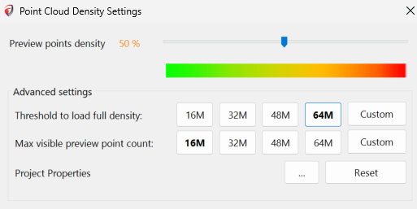 |  | Point Cloud Density Settings:  Threshold for Loading Full Density: The range is typically 12-48 million points. For powerful computers, you can increase this range to 48-72+ million points.  Maximum Visible Preview Point Count: A minimum of 16 million points is recommended, with an optimal range of 16-36+ million points.  Project Point Resolution Information: In the properties section, you can check the loaded project’s preview and full-resolution points count.
 | Hide/Show | Hides or shows the point cloud.
 | Clipping Box Visibility | Toggles the visibility of the clipping box boundary on or off.
 | Grips | Adjusts the orientation of clipping box grips.
 | Delete | Removes the selected view section or clipping box.

    - Bottom tools of Scan Data toolbox: Smart Indicator and point cloud snapping modes
 | Clip in Clip | Enables the creation of a new clipping box within an existing clipping box.
 | Snap to Point Cloud | Enables/Disables snapping to point cloud points.
 | Snapping Options: | N – Snaps to Nearest point  H – Snaps to the Highest point Z value  L – Snaps to the Lowest point Z value
 | Search radius for finding the highest or lowest point.
 | Smart Indicator | Helps you understand which source you are using:
 |  | You see only preview points according to your settings for “Max visible preview point count.”
 |  | If fewer points are inside your clipping box (view section) than the “Threshold to load full density” value, you will see this colour.
 |  | You will see the yellow colour only when you have an active point cloud clipping and the “Max visible preview point count” value is equal to or higher than the “Preview point count” value of the entire project.
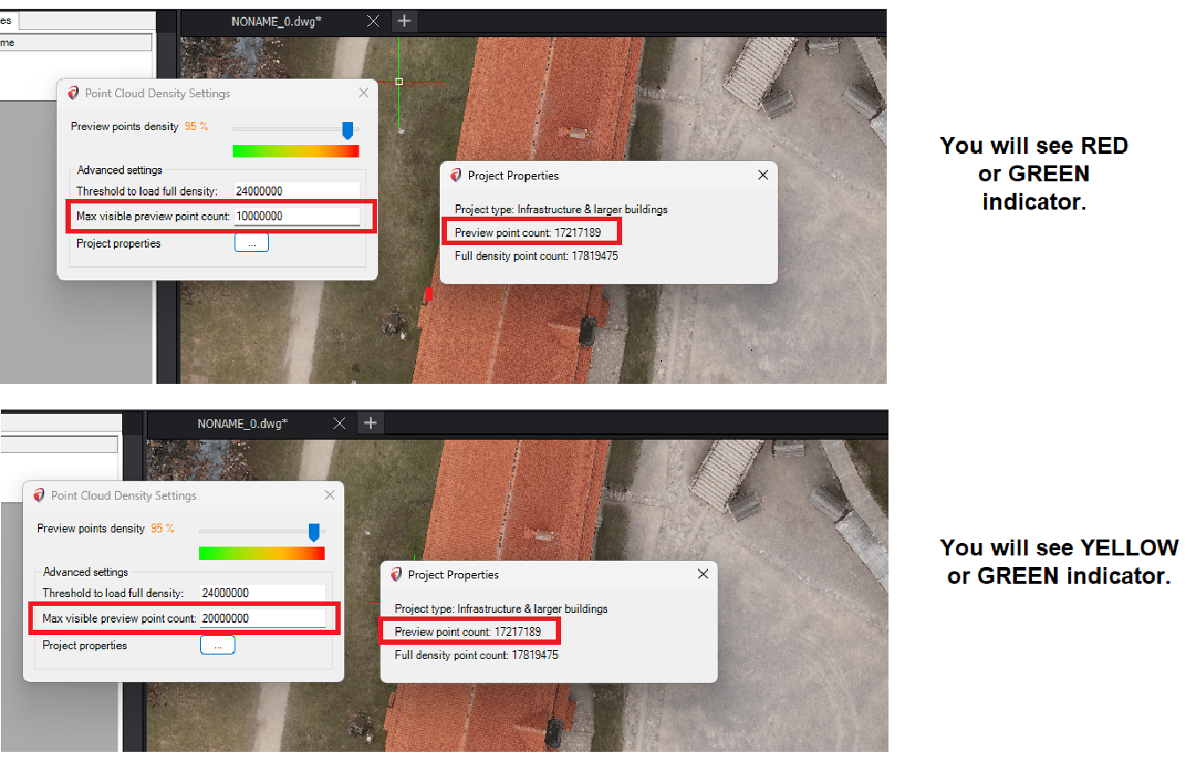
  - Logic Classes
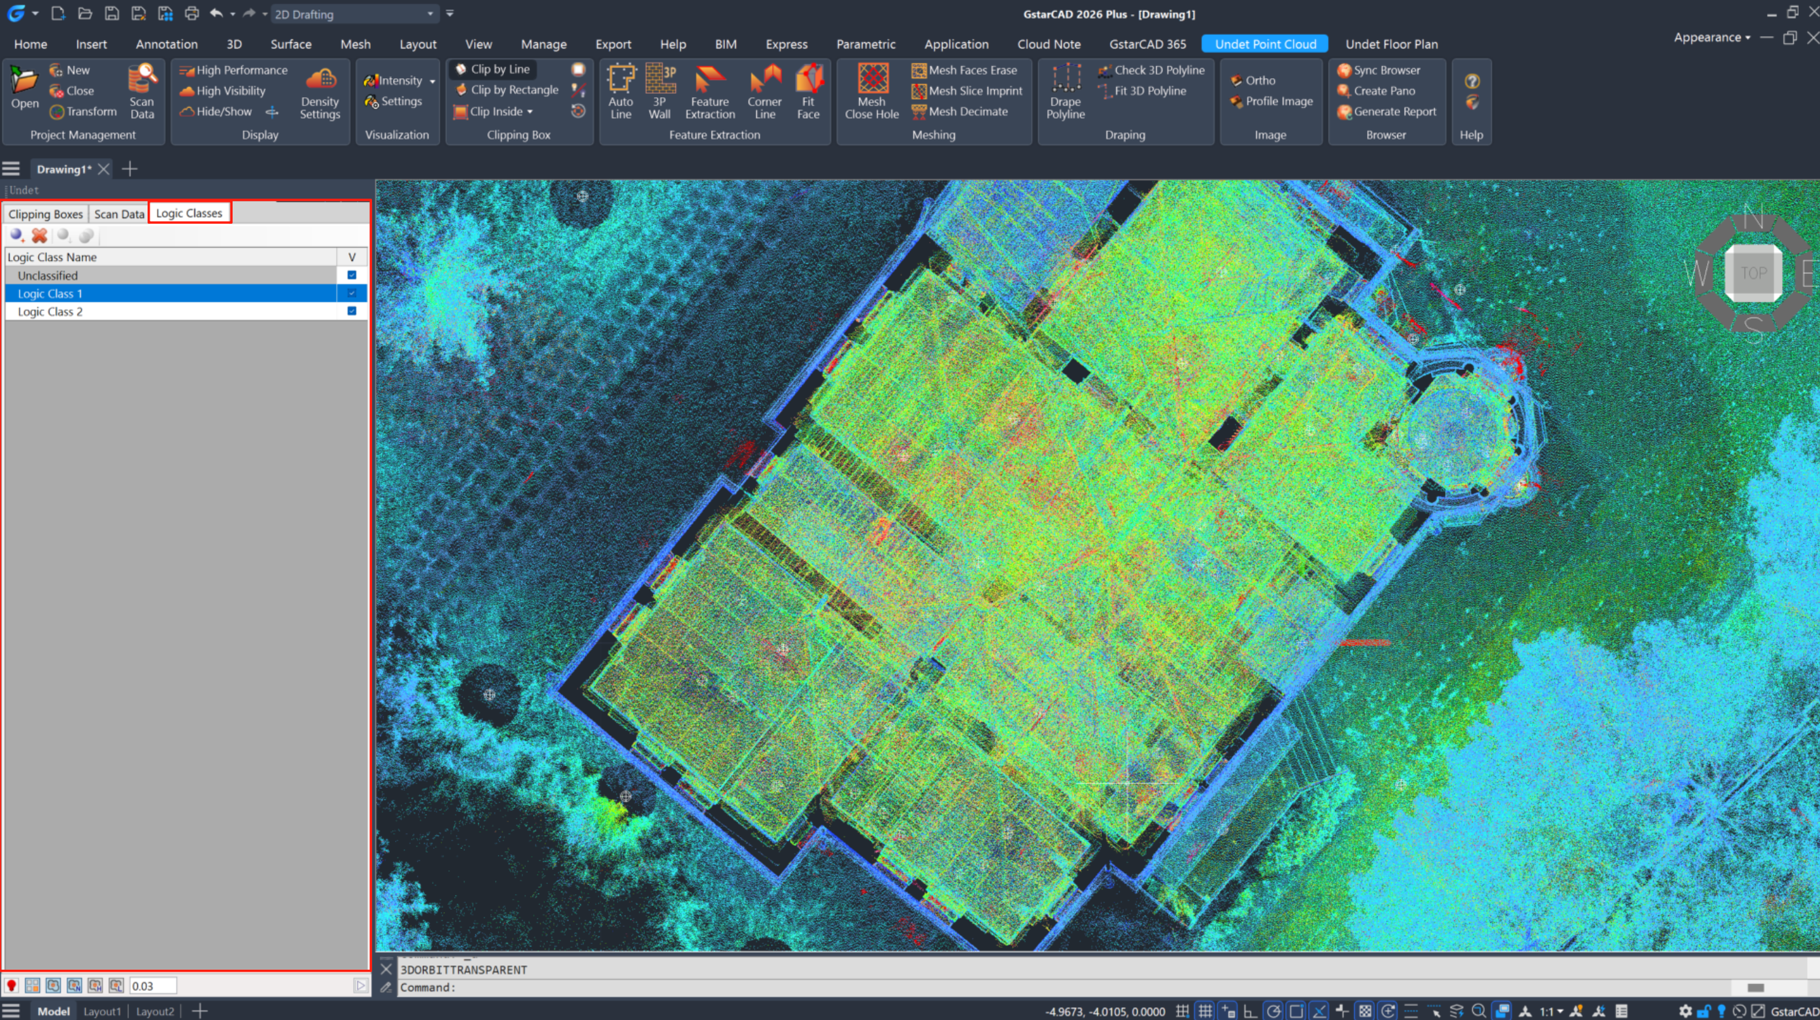
You can create, edit and assign Logic Classes into different groups, classify View Sections or parts of View Sections by Logic Classes.
Usually if Your project is created from terrestrial laser scanner data, it will not have any logical classes created. But if your project is created with mobile or LiDAR scanners, it might have Logical Classes classified.
GstarCAD Point Cloud 2026 will recognize them and you will be able to manage them directly from Logical Classes tab.
 | [Add Class] – Creates new empty Logic Class
 | [Remove] – Removes selected Group from the List. Program removes only Group, but not Data Files, assigned to it. After deleting Group, Data Files remain in the List.
 | [Classify] – Moves active View Section points to defined Logic Class. You can create new Logic Class or choose existing one from the launched dialog list.
 | [Merge] – Merges selected Logic Classes to the first Class of selected items. Select several Logic Classes with Shift button and merge them into one Logic Class.

- Right-click menu
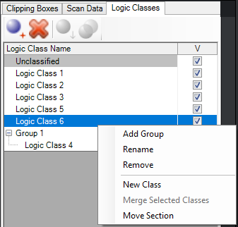
Add Group | Creates a new group or merges selected Logical Classes to new group.  Quick tip: You can select multiple files at once by holding Ctrl or Shift button.
Rename | Rename any Logic Class in the List
Remove | Removes selected Group from the List. Program removes only Group, but not Data Files, assigned to it. After deleting Group, Data Files remain in the List.
New Class | Creates new empty Logic Class
Merge Selected Classes | Merges selected Logic Classes to the first Class of selected items. Select several Logic Classes with Shift button and merge them into one Logic Class.
Move Section | Moves and changes selected record position inside the Group on the Logical Classes List.

Logic Classes List shows and helps to manage all created Logic Classes.
- To create New Class in the List, right click on any created Logic Class and choose New Class command from the context menu.
- To move Active View Section or cropped part of Active View Section to specified Logic Class, right click on selected Logic Class and choose Classify command from the context menu.
- To assign created Logic Classes into Group, select Classes you want to assign (use Shift or Ctrl buttons to select multiple Classes) and choose Add Group command from the context menu.
- To rename any Logic Class in the List, double click on its name or right click on it, choose Rename command from the context menu and type the new name.
- To remove any Logic Class from the List, right click on it and choose Remove command from the context menu.
- Check Tick-Mark in V column next to corresponding Logic Class’s name if you want this Class to be visible in the drawing.

Display
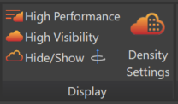
- High Performance: Activates the best performance density settings.
Density Settings: Preview point density set to 50%.
- High Visibility: Activates the best visibility density settings.
Density Settings: Preview point density set to 100%.
- Hide/Show: Toggles the visibility of the point cloud on and off.
- Density Settings:
  - Threshold to Load Full Density: Typically set between 12-48 million points. For powerful computers, this can be increased to 48-64+ million points.
  - Maximum Visible Preview Point Count: The minimum is set to 16 million points, with a recommended range of 16-36+ million points.

How to Determine Suitable Settings for Your Hardware:
It’s straightforward. The fundamental principle with Undet is to keep the point cloud light. If GstarCAD lags during view rotation, zooming, or panning, it indicates that too many point cloud points have been loaded.

Undet File Structure: Undet utilizes a dual file structure—preview points and full-resolution points. Preview point density and full-resolution point count are managed separately.
Preview points Grid: This can be set when creating a point cloud project in Undet Indexer.
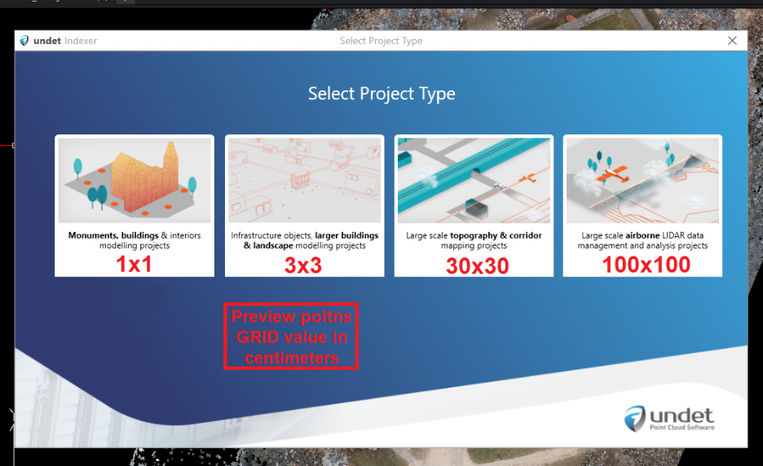
In the properties, you can verify the loaded project’s preview and full-resolution points count.

Visualization
- Colouring by… - options:
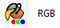 | RGB | Colours the point cloud based on RGB (true colours).
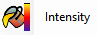 | Intensity | Colours the point cloud based on Intensity.
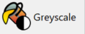 | Greyscale | Colors the point cloud in Black & White.
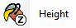 | Height | Colours the point cloud based on Height (Z value).
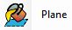 | Plane | Colours the point cloud based on Selected Plane (plane can be chosen in settings).
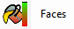 | Faces | Colours the point cloud based on the Distance from modelled 3D faces.

- Settings:
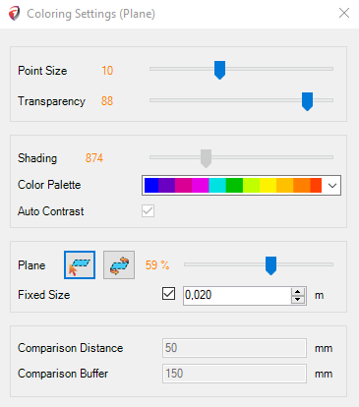
  - Point size slider: Adjusts the size of points.
  - Transparency slider: Adjusts the transparency of the point cloud.
  - Shading: Utilizes colours from the colouring palette in shading (colour count/percents of the palette used)
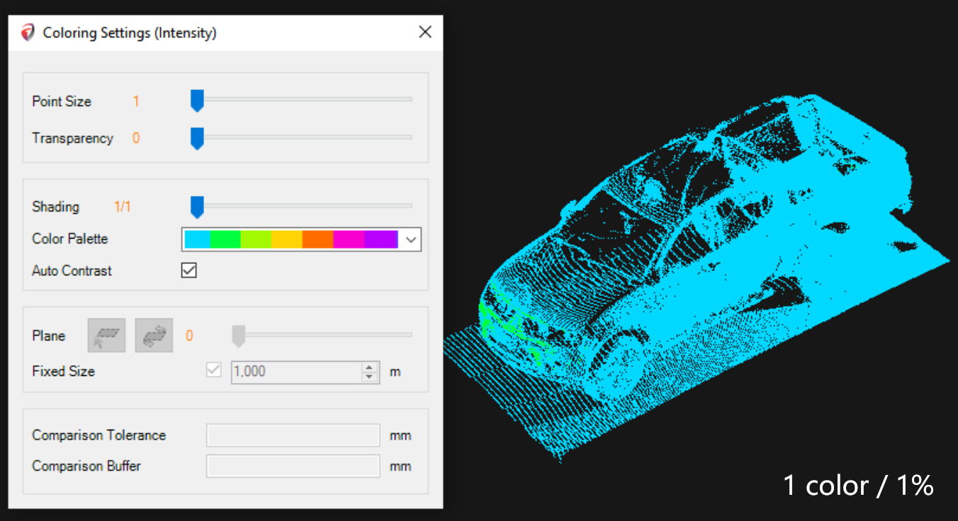
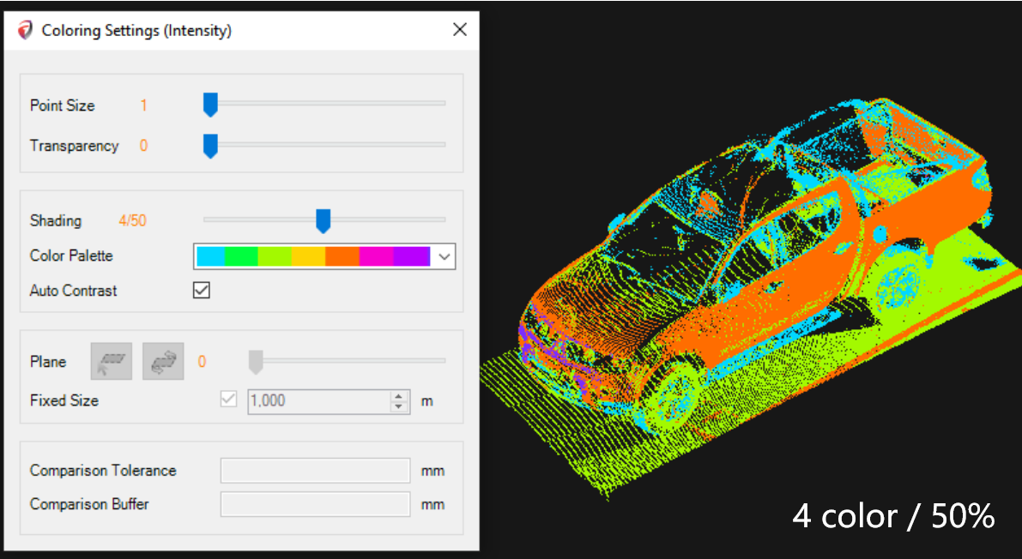
- Color Palette: Allows you to select a colouring palette for the best visibility/results.
- Auto Contrast: Automatically finds the best contrast option.
- Plane Settings (used with colouring by plane)
    - 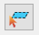Choose plane: Select a plane by mouse click.
    - 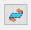Flip plane: Reverse colouring by selected plane.
    - Slider: Adjusts the percentage of the visible view coloured from the plane.
- Fixed-size: Determines the distance of colour changes (if the Fixed Size box is unchecked, you can use shading settings).
- Comparison settings (used with colouring by faces)
  - Comparison Distance: Colours areas within the chosen tolerance in green from the 3D model.
  - Comparison Buffer: Specifies the maximum distance to be coloured from the model.

In this example, everything within a 30mm radius is coloured in green, while everything between 30-200mm is coloured in red as defined in settings.
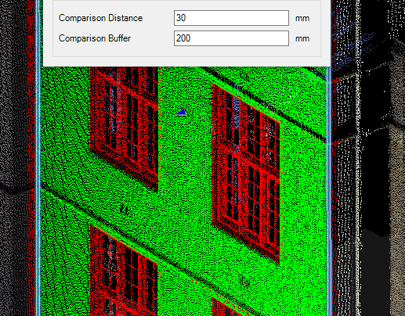

Clipping Box
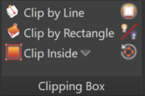
- Clip by Line: Creates a new clipping box defined by line and thickness: Optional Inputs from the command line.
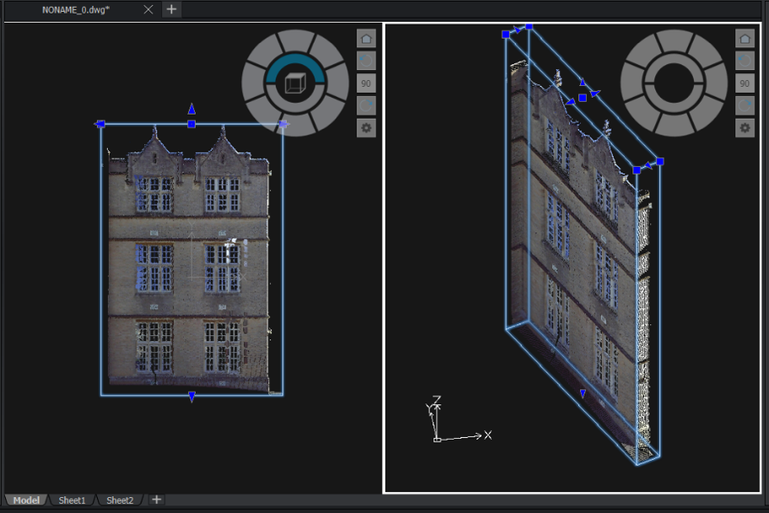
  - T – Thickness: Choose thickness (default – 1 meter).
  - U – UCS: Create a new UCS based on your clipping box.
  - V – View: Create a new view based on your clipping box.
  - A – UCS and View: Create a new UCS and view based on your clipping box.

- Clip by Rectangle: Creates a new clipping box defined by a rectangle.
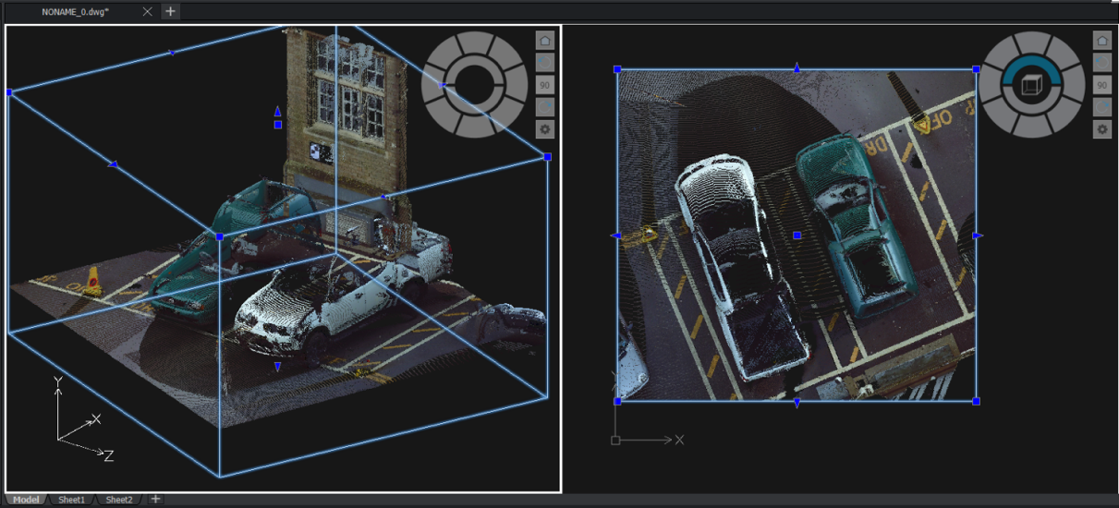
- Clip Inside: Defines polygon selection to clip the points inside of the selected area.
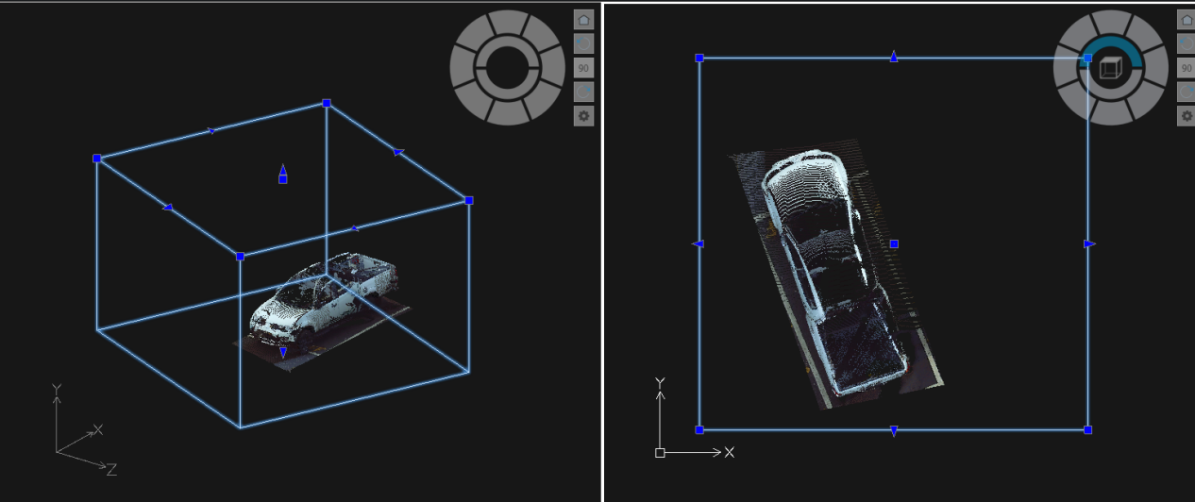
- 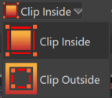 Clip outside: Defines polygon selection to clip the points outside of the selected area.
- Deactivate: Deactivates active point cloud clipping to see the entire point cloud.
- Clipping Box visibility: Toggles the visibility of the clipping box boundary on or off.
- Grips: Changes the orientation of clipping box grips. Shortcut: (Ctrl + Shift + 1)

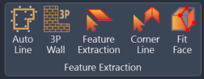
Feature Extraction
This tab provides various feature extraction tools to enhance your CAD drawing experience. These tools automatically recognize and extract specific features from point cloud data.

Auto Line
Auto Line tool automatically detects and extracts linear features from your CAD drawings, improving workflow efficiency.
The tool automatically recognizes wall lines from 3D point cloud scans with a single click. Subsequent clicks allow you to create a continuous polyline effortlessly.
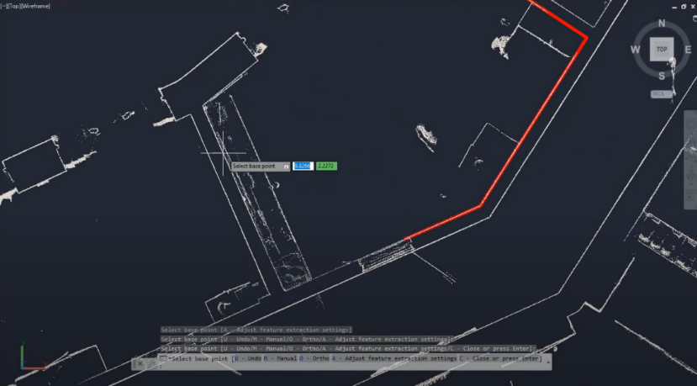
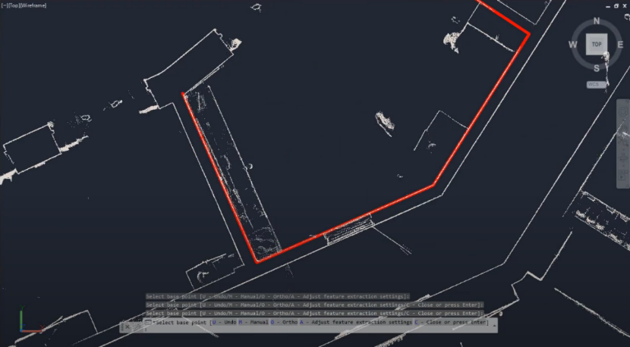
Advanced Options:
In cases where there are insufficient points for automatic recognition, the tool offers advanced options to prevent workflow interruptions.
- Ortho Mode: Enabling Ortho Mode in the advanced settings permits you to add line segments perpendicular to the previous line, ensuring precision in your drawings.
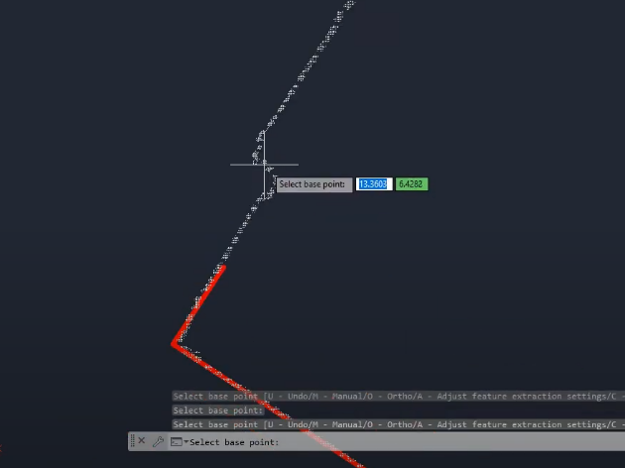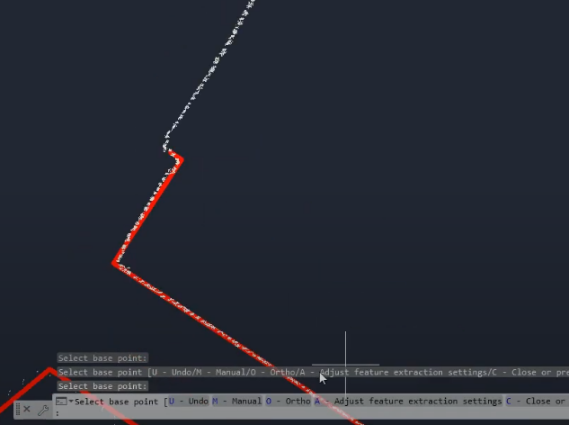
- Manual Mode: In Manual Mode, you can add the following line segment with just two clicks in any direction, accommodating various scenarios and drawing needs.
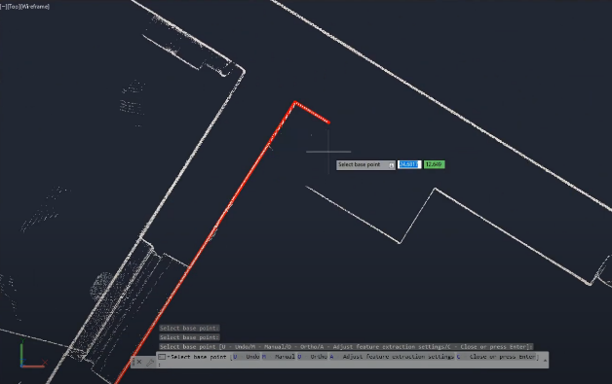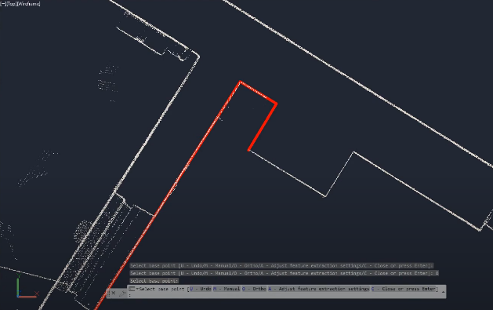

3P Wall
The 3P Wall tool allows users to create walls using three points: two points define the length, and the third point sets the width. In the command line, users can choose between Single mode to draw individual walls or Chain mode to create a series of connected walls seamlessly.
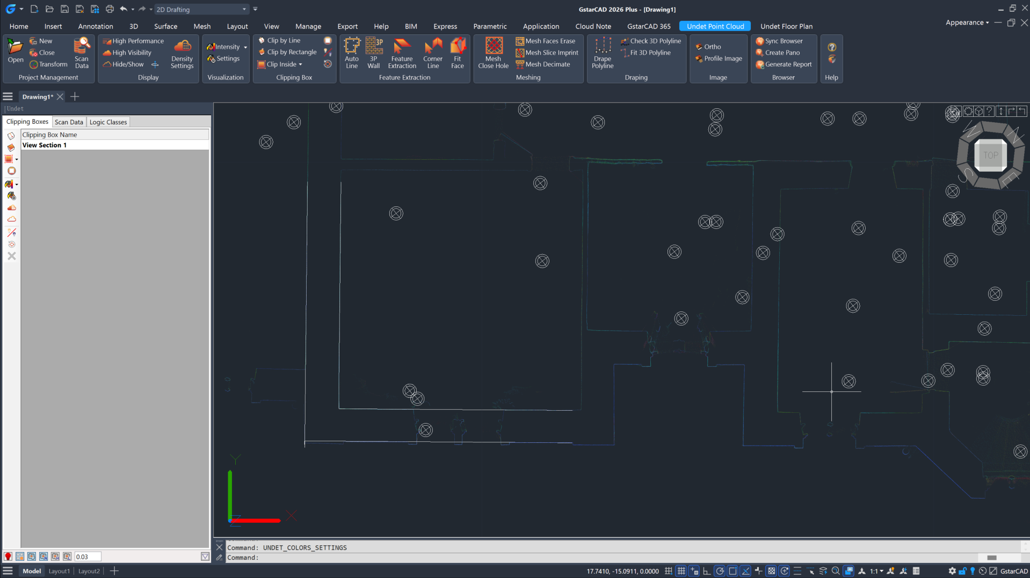

Feature Extraction
Feature Extraction tool opens automatic feature extraction settings. Recognizes walls, ground, or other planes within point cloud data and creates a mesh based on selected parameters. You can edit these parameters after creating the mesh.
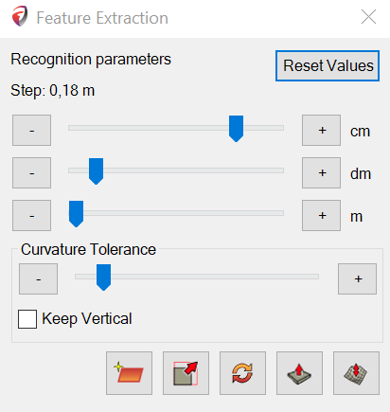
- Reset Values: Resets step size to default.
- Step size sliders: The step size value should be 3-5x bigger than the point cloud density (distance between neighbouring points).
A Bigger step means a bigger distance between point cloud points for plane extraction. You can extract large planes (for example, walls, columns, and roof plane window frames) by selecting a bigger value.
A Smaller step means, a smaller distance between point cloud points for plane extraction. By selecting a small value, you can extract smaller planes (for example, windows frames and door frames).
- Curvature Tolerance slider: If the surface is bumpy or curvy, you will be able to create a detailed mesh and capture small bumps and curves by increasing tolerance.
- Keep Vertical: If a checkmark is placed, the extracted plane will stay in the vertical position.
- 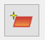 Find Plane: Select the initial point location to extract the plane.
- 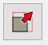 Scale: Extracted plane scale function.
- 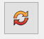 Rotate: Extracted plane rotate function.
- 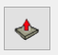 Push/Pull: Extracted plane press & pull function.
- 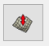 Convert to Mesh: Finds and creates surface mesh according to the extracted plane. The command is inactive if no plane is selected.

Example: Plane Recognition settings
Poorly recognized plane (Step size 0.04 m) | Well-recognized plane (Step size 0.06 m)
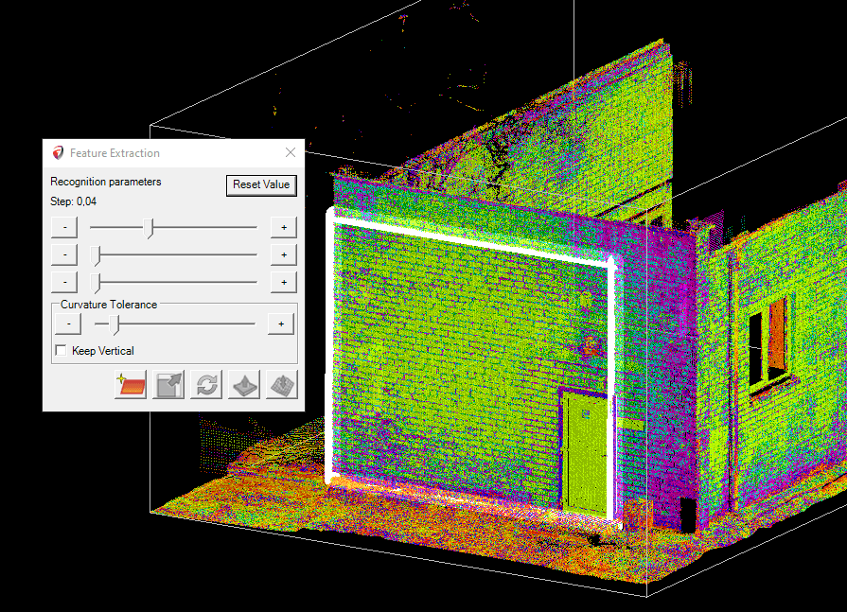 | 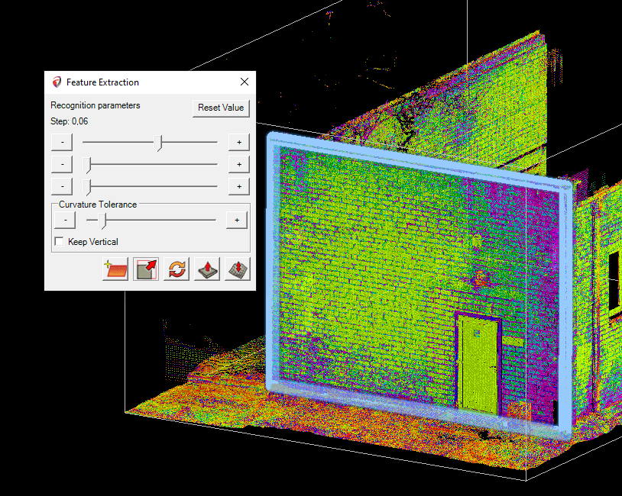
Example: Surface creation with small step size and different Curvature Tolerance.
(Step size 0.34 m)  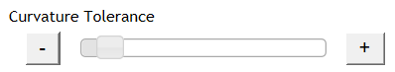 | (Step size 0.34 m)  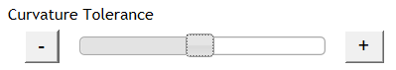
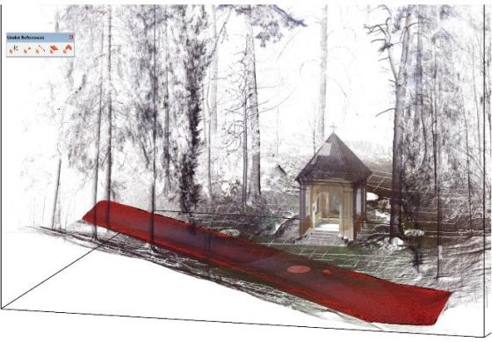 | 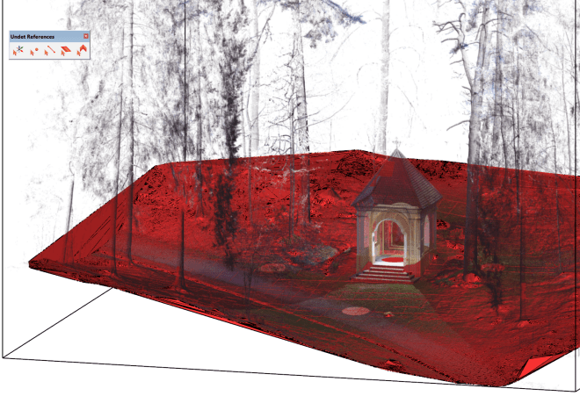
The detailed ground mesh was created until the first bigger bump | Detailed ground mesh was created in all areas

Example: Surface creation with a bigger step size. A Bigger step means a more decimated mesh without small bumps and curves.
(Step size 1.34 m) | (Step size 1.34 m) increased “Curve Tolerance.”
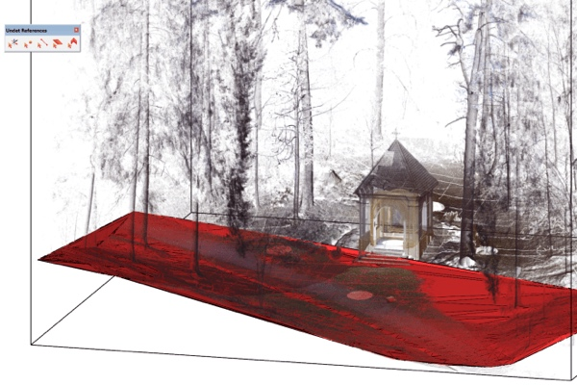 | 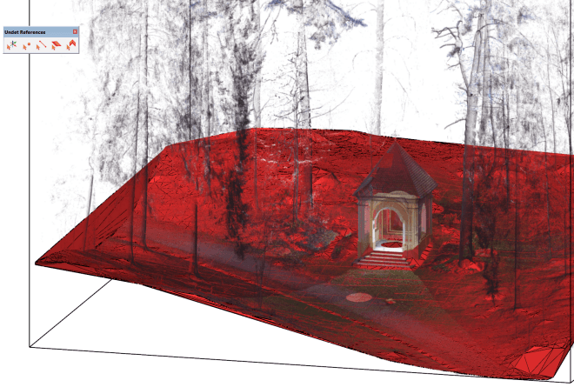
The detailed ground mesh was created until the first bigger bump | Detailed ground mesh created in all areas
A ground surface mesh can be created from an unclassified point cloud.
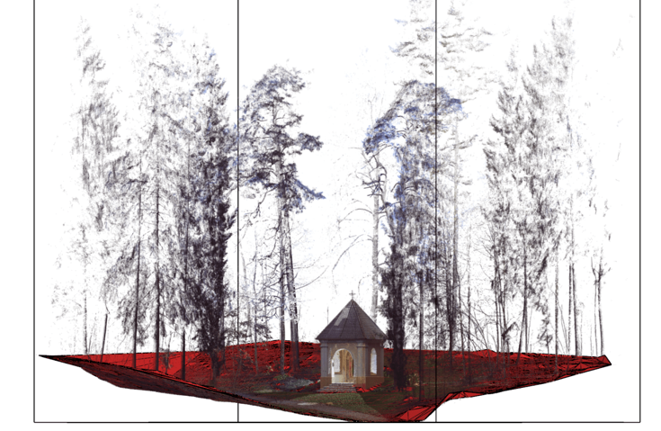

Corner Line
Corner Line tool recognizes and draws a line on a corner by selecting two walls (SNAP point cloud nodes).
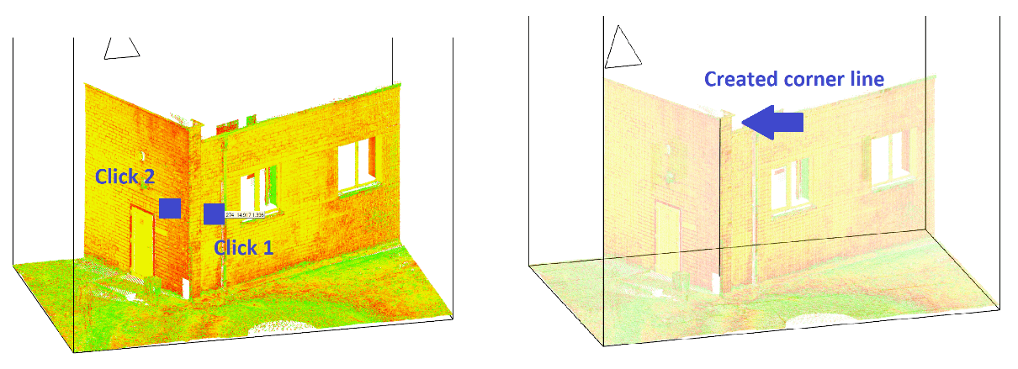

Fit Face
Fit Face tool Opens automatic feature extraction settings. Recognizes walls, ground, or other planes within point cloud data and creates a mesh based on selected parameters. You can edit these parameters after creating the mesh.

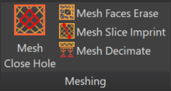
Meshing
This section provides tools for editing and modifying meshes within your CAD drawings.

Mesh Close Hole
Closes a mesh hole by selecting the edge line of the hole (Only in Wireframe visual style).
Locate the hole in the mesh and specify the edge | Automatically interpolated and closed hole
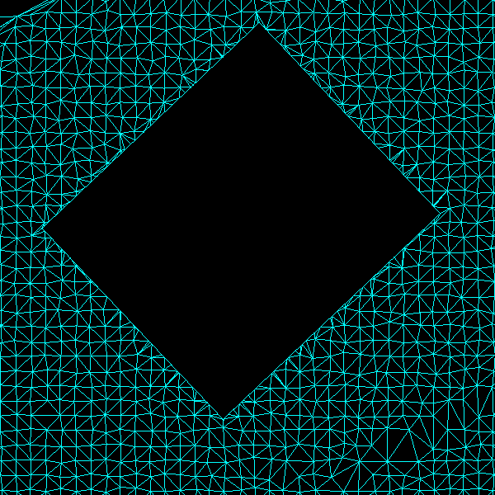 | 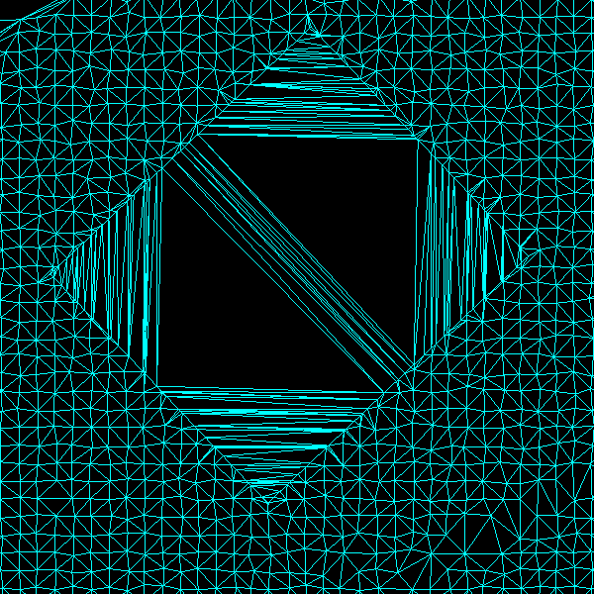

Mesh Faces Erase
Erases created mesh faces.
Select faces which need to be deleted by drawing a polygon | All faces that were selected by the defined polygon were deleted
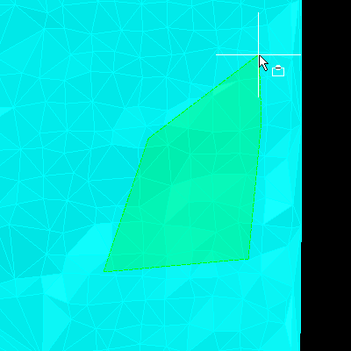 | 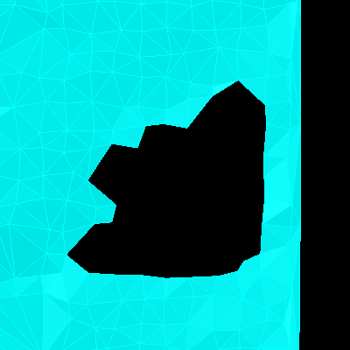

Mesh Slice Imprint
Slice the mesh or imprint your drawn lines, rectangles, and other shapes into the mesh.
Mesh Slice Imprint functionality in the command line:
- Projection plane selection
Select the projection plane from WCS (world coordinate system) or UCS (user coordinate system).
- Action type selection
Select mesh action type:
  - Imprint – adjust mesh vertices (3D geometry) to a reference 3D line.
  - Slice – divide the selected mesh into separate meshes defined by the selected drawn object.
  - Projection – will generate a projection line on top of the mesh surface defined by the selected drawn object.
  - Projection and slice- will generate a projection line on top of the mesh surface defined by the selected drawn object and will divide the selected mesh into separate meshes defined by the selected drawn object.
- Mesh selection
Select the mesh to which actions will be applied.
- Object selection
Select a drawn object which will be defined previously.

Mesh Decimate
It shows the mesh’s number of faces and allows you to reduce the number of faces (type a value from 0 to 1 (1=100%, 0.5=50%, 0.1=10%...)
Site mesh with all faces (100%)  (face count: 200414) | Site mesh with decimated faces (5%)  (face count: 10020)
 | 

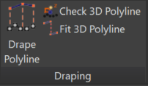
Draping
This section provides various tools for working with polylines and point clouds.

Drape Polyline
Drapes your drawn polylines, points, etc., to point cloud points or 3D mesh surface.
Select polyline and press enter. | Object vertexes will be snapped to the closest point cloud points.
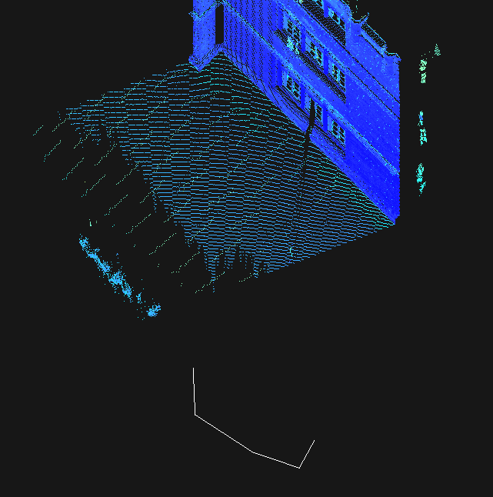 | 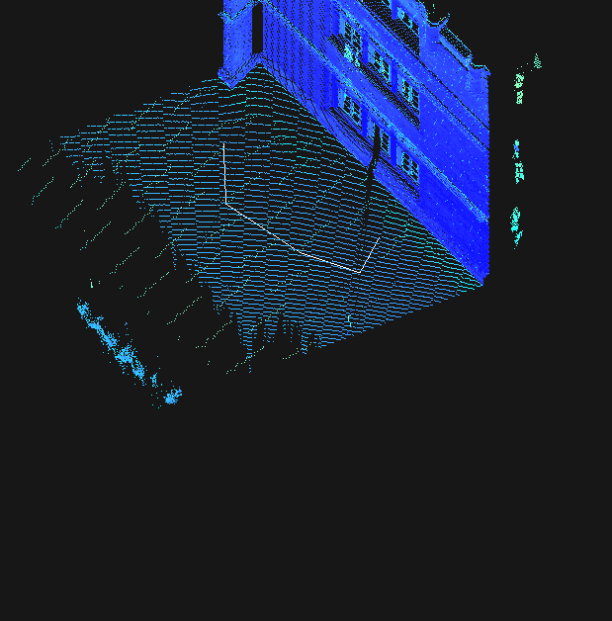

Check 3D Polyline
Check selected points and polyline breakpoints, cutting the point cloud at each end.

Fit 3D Polyline
Joins selected polylines Z positions if their XY coordinates are the same.
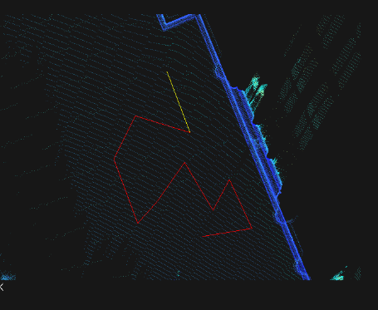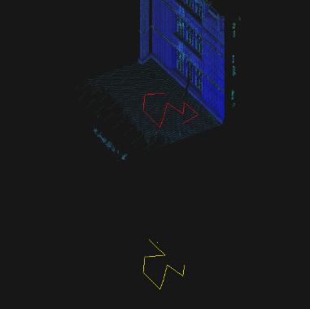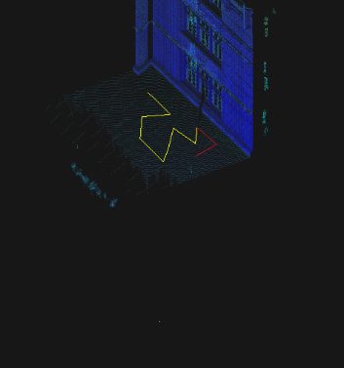
- Polyline XY coordinates are the same.
- First, select the base 3D polyline. Second, select the polyline you want the Z position to change.
- The second selected polyline was fit to match the first selection Z coordinates

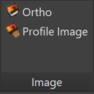
Image

Ortho
Creates raster images by specifying an area.
Settings: 5mm, Visible (Loaded) Points | Settings: 5mm, Full Resolution points
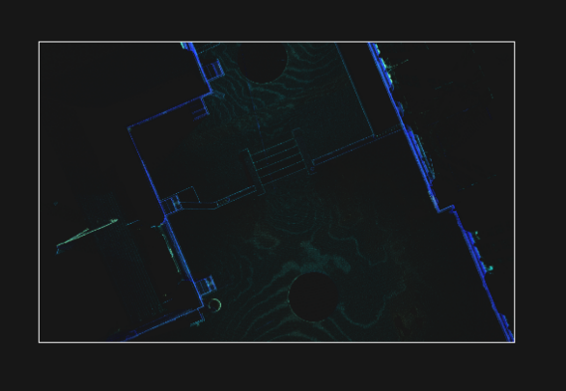 | 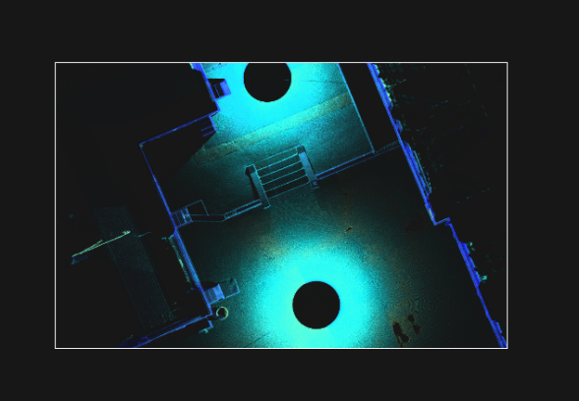
Settings: 1mm, Full Resolution points | Settings: 10mm, Full Resolution points
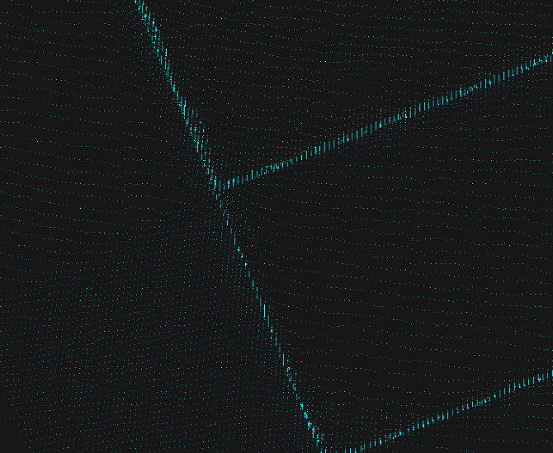 | 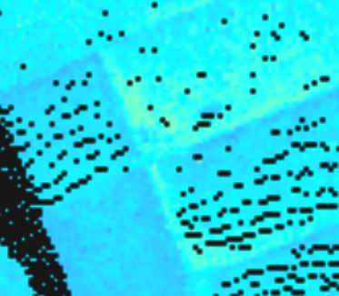

Profile Image
Generates profile image on plan view without changing UCS or view orientation.
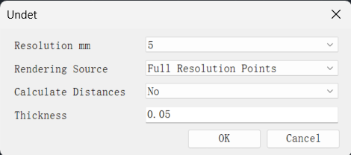
- Resolution mm: Choose image resolution (1 to 100 millimeters).
- Rendering source: Choose to render from visible (loaded) or full-resolution point cloud points.
- Calculate Distances: Select ‘Yes’ to arrange points from the farthest to the closest based on their distance. Choose ‘No’ for random point selection.
- Thickness: Specify thickness for profile slice.

Example. Facade view without profile image | Example. Facade view with profile image
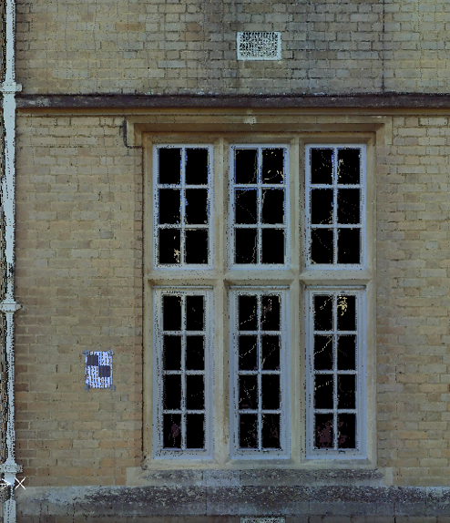 | 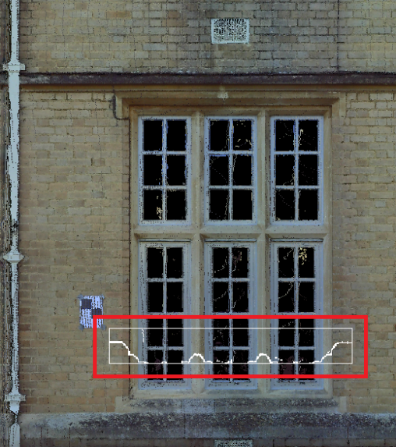

Browser
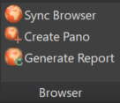
- Sync Browser: Locates Undet Browser view by clicking on point cloud point (snapping to pint cloud points needs to be turned on)
- Create Pano: Creates new 3D panorama view for Undet browser
  - All: creates pano from all visible and hidden scan positions
  - Shown: creates pano from all visible scan positions

Creating Pano by picking an object:
- Create an object (node – command “POINT”) where you want your pano view center to be created.
- Press the Create Pano button -> choose all or shown -> select your object (or objects) -> enter radius (in meters) -> enter group name.
- Your Pano is created, and you can find it in Undet Browser by selecting the new group category you just created.
Creating Pano by picking point:
- Note: don’t forget to turn on snapping to point cloud when creating by picking a point
- Press the Create Pano button -> choose all or shown -> snap picking point-to-point cloud or object -> enter radius (in meters) -> enter group name.
- Your Pano is created, and you can find it in Undet Browser by selecting the new group category you just created.

- Generate Report: Generates Model Inspection QC report based on 360-degree scan station images in Undet Browser to ensure the accuracy of the 3D model.
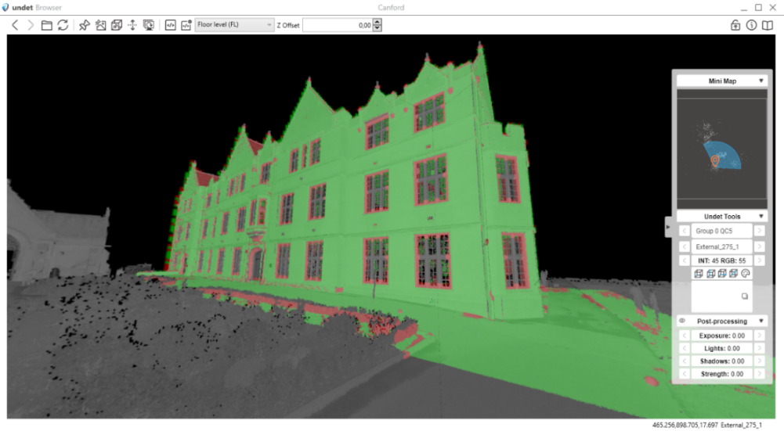
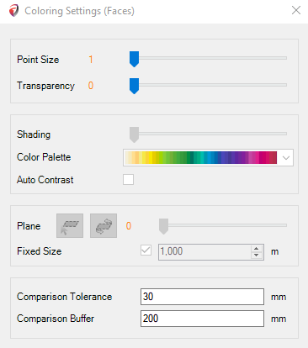
To generate the report:
- You will need to set Comparison Tolerance and Buffer in Coloring settings (Visualization Tab)
- Turn your point cloud, 3D models and scan positions on.
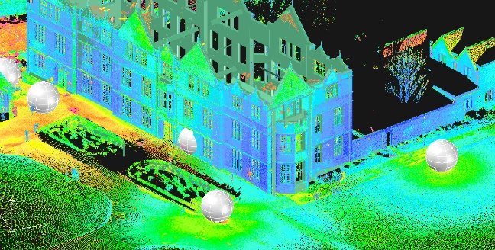
- Click on Generate Report and adjust settings.
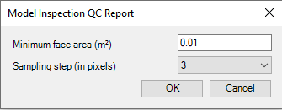
- Choose the scan positions you want to analyze and press enter twice.
GstarCAD will generate 360 images by colouring and comparing them with your planes (floors, walls, ceilings, etc.)
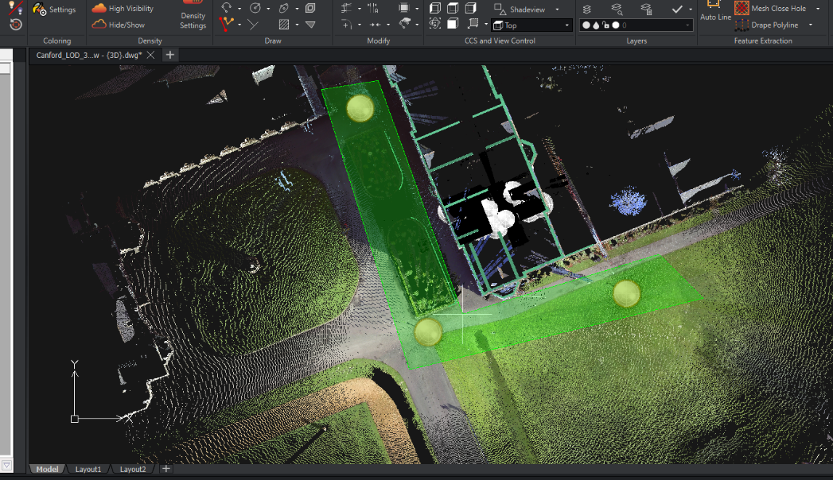
- Go to the Undet browser and choose the newly created group.
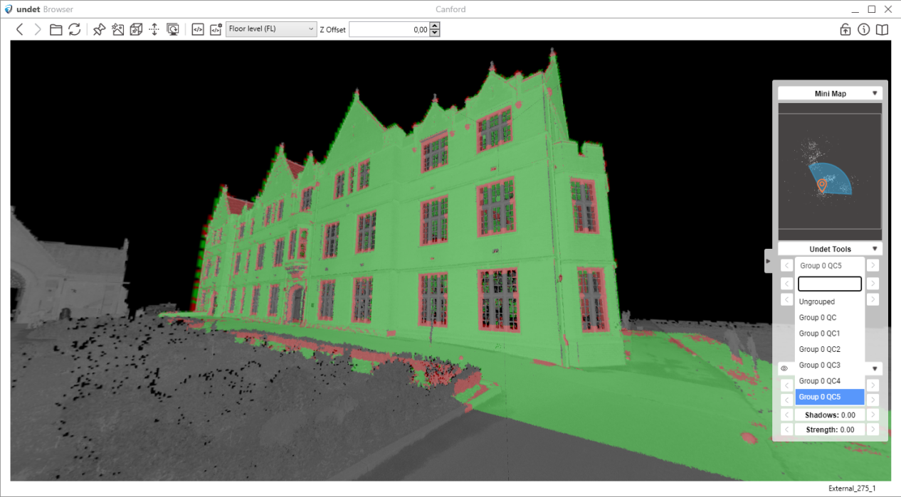

Help
User Guide: opens GstarCAD Point Cloud User Manual
About: access detailed information about your license and activation.

Undet Floor Plan Tab
The Undet Floor Plan tab is for faster floor plan vectorization and adding details & annotations to floor plan drawings in GstarCAD. It comes with various tools that make it easy to vectorize floor plane views, add windows & doors, and add annotations and other notes to your drawings.

Point Cloud
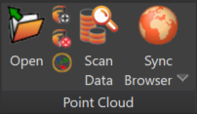
 | Open | Allows you to open an existing point cloud project
 | New | Opens the Undet Indexer to create a new point cloud project
 | Close | Closes the current point cloud project
 | Transform | Opens the Coordinate System Manager for moving/rotating point cloud coordinates.
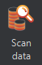 | Scan data | Opens Scan Data toolbox.  For more detailed information on the tools mentioned above, refer to the first part of this document: Undet Point Cloud – 1.1 Project Management.
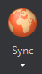 | Sync Browser | Locates Undet Browser view by clicking on point cloud point (snapping to pint cloud points must be turned on).
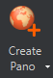 | Create Pano | Creates new 3D panorama view for Undet browser.  For more detailed information about the above tools, refer to the first part of this document: Undet Point Cloud – 1.9 Browser.

Section View
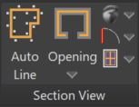
-  Auto Line tool automatically detects and extracts linear features from the point cloud slice.
The tool automatically recognizes lines from 3D point cloud scans with a single click. Subsequent clicks allow you to create a continuous polyline effortlessly.
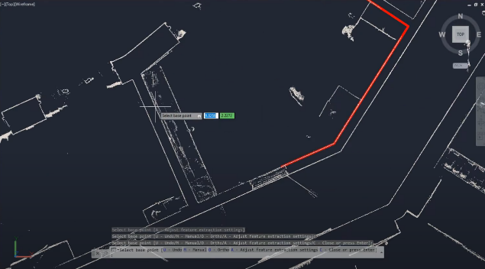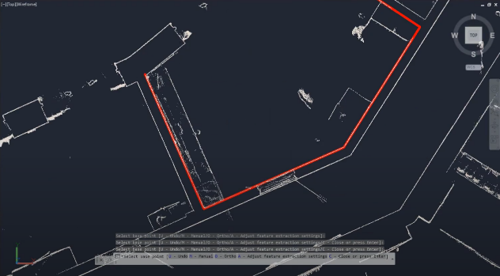
Advanced Options: In cases where there are insufficient points for automatic recognition, the tool offers advanced options to prevent workflow interruptions.
  - Ortho Mode: Enabling Ortho Mode in the advanced settings permits you to add line segments perpendicular to the previous line, ensuring precision in your drawings.
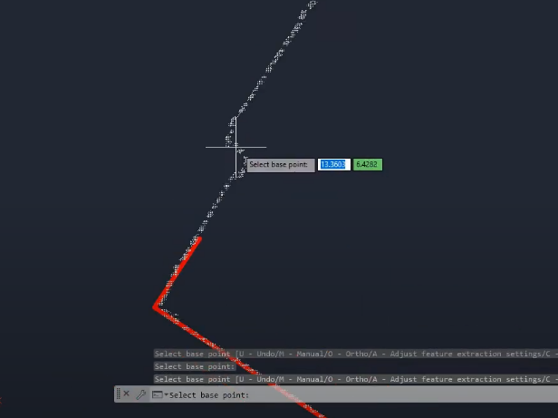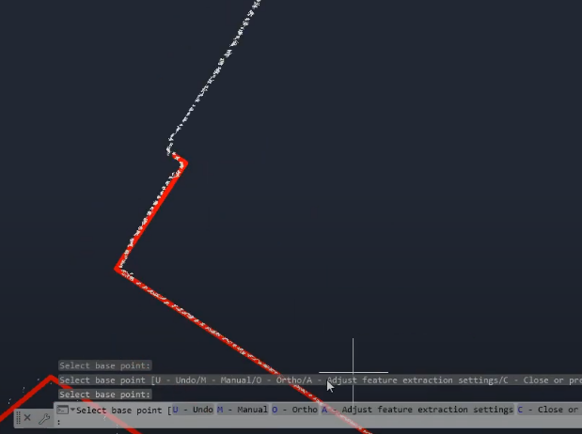
  - Manual Mode: In Manual Mode, you can add the following line segment with just two clicks in any direction, accommodating various scenarios and drawing needs.
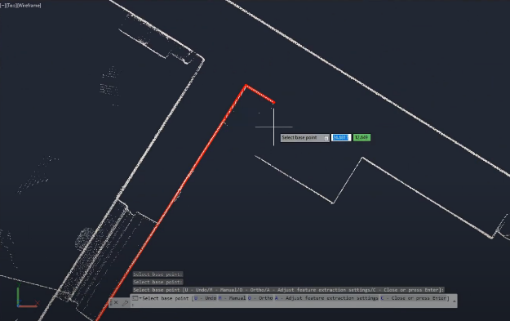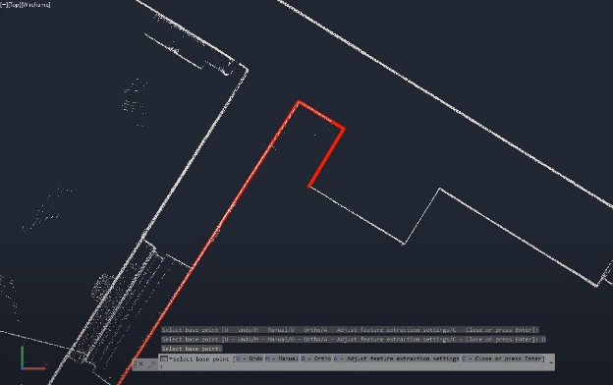
- 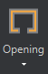 Opening: Adds opening in the wall by specifying two cut points
First point specification  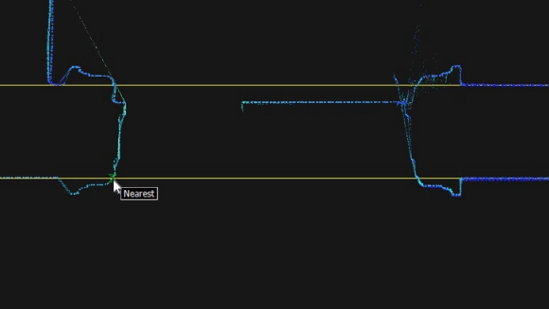 | Second point specification  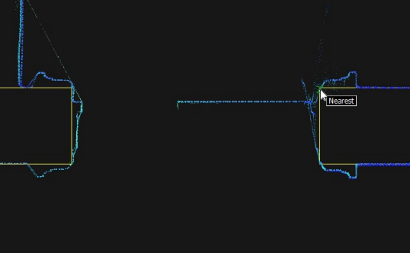

- 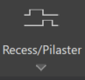 Recess/Pilaster: Creates a recess object
1. Select Line  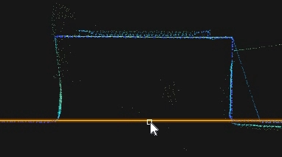 | 2. Select the first cut point  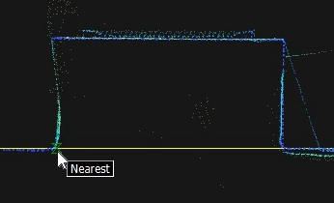
3. Select a second cut point  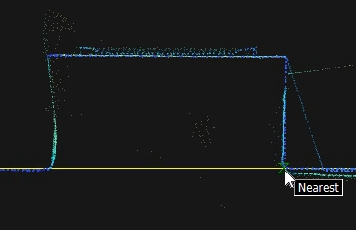 | 4. Select displacement point  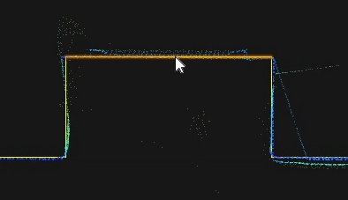
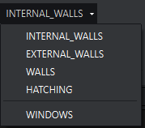
- Drop-down menu, which shows quick layer selection.
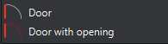
- To place the door to the existing opening, use Door (first, you will need to select the line to align the door).

To place a Door with an opening:
- Specify the first cut point.  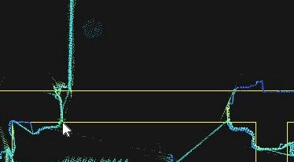 | - Specify the second cut point  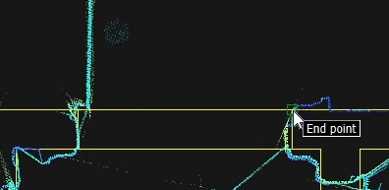
- Specify insert point.  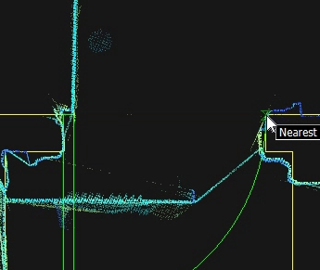 | - Press escape and click on the inserted door. By using arrows, place your door in the right direction  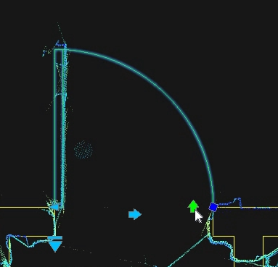

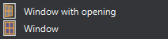
- To place the window to the existing opening, select Window (first, you must choose a line to align the window).

To place a Window with an opening:
1. Specify the first cut point.  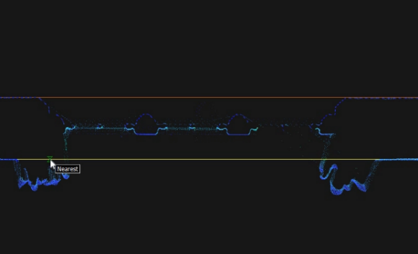 | 2. Specify the second cut point.  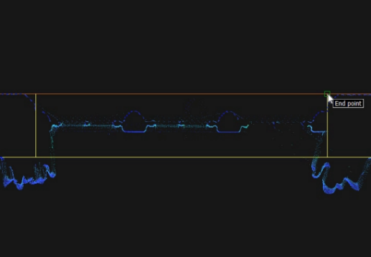
3. Specify insert point.  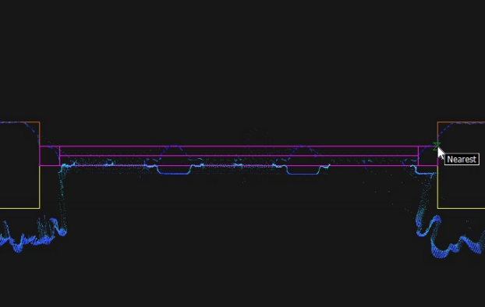 | - Press escape and click on the inserted window. By using arrows, specify your window size  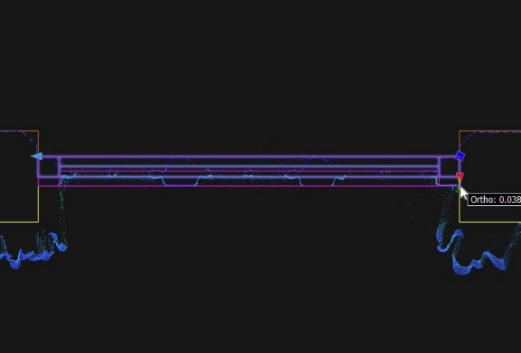

Floor View
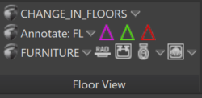
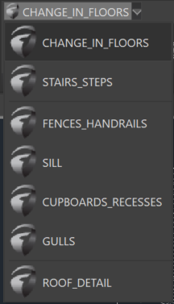
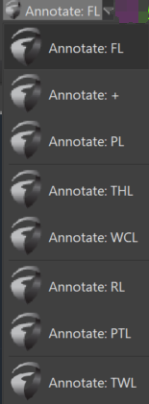
- CHANGE_IN_FLOORS drop-down menu: which prepares layers for drafting selected lines.
- Floor Annotations drop-down menu:
  - FL: Annotates floor level
  - +: Annotates floor level at the point
  - PL: Annotates plinth level
  - THL: Annotates threshold level
  - WCL: Annotates window sill level
  - RL: Annotates roof level
  - PTL: Annotates parapet level
  - TWL: Annotates wall level
- Direction arrows:
  - : Add stairs up the direction arrow.
  - : Add a sloping wall direction arrow.
  - : Add floor slope direction arrow.
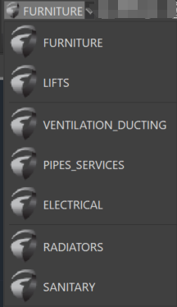
- FURNITURE drop-down menu: The dropdown menu lets you quickly select the required layer for point cloud vectorization.
- Insert Blocks:
  - : Radiator
  - : Sink
  - 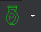: WC, WC with a tank, Urinal, Bidet
  - 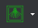: Shower, Bathtub

To insert blocks:
1. Select Origin Line.  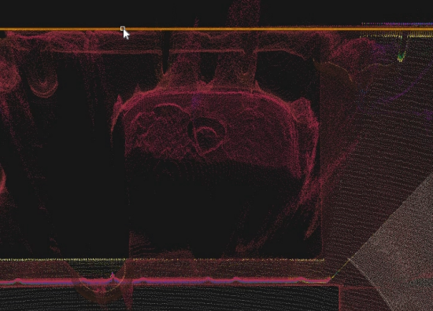 | 2. Specify destination point.  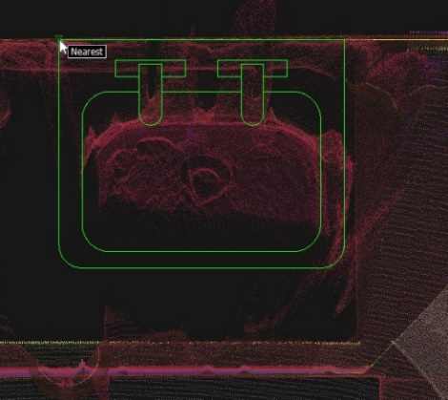
3. Specify object position angle.  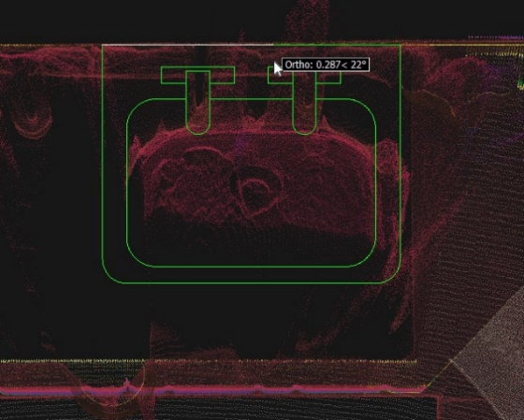 | 4. Click on the placed block and stretch it using arrows.  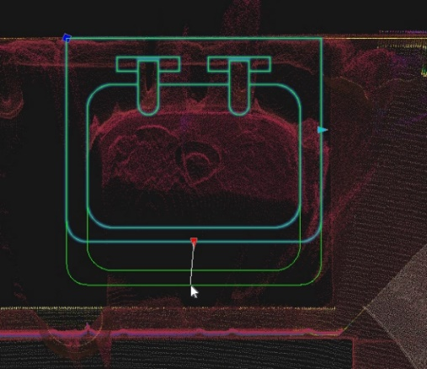

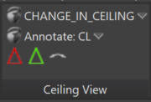
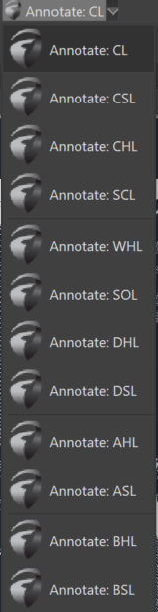
Ceiling View
- CHANGE_IN_CEILING dropdown menu: allows you to quickly select the layers for faster point cloud slice vectorization.
- Ceiling Annotations drop-down menu:
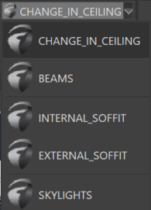
  - CL: Ceiling level
  - CSL: Arch ceiling springer level
  - CHL: Ceiling head level
  - SCL: Structural ceiling level
  - WHL: Window head level
  - SOL: Soffit level
  - DHL: Door head level
  - DSL: Arch door springer level
  - AHL: Arch head level
  - ASL: Arch springer level
  - BHL: Beam head level
  - BSL: Beam soffit level
- : Beam slope direction arrow
- : Ceiling slope direction arrow
- : Arch symbol

Axis
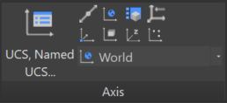
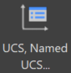 | Axis Manager | Save new, delete or rename UCS views.
 | Draw Axis | Creates 2D polyline to AXIS layer.
 | UCS, Origin | Defines a new UCS by shifting the origin point.
 | UCS, World | Sets UCS to world coordinate system
 | UCS, Object | Aligns the UCS to a selected object.
 | UCS, View | Aligns the XY plane of the UCS with the screen.
 | UCS, Z Axis Vector | Aligns the UCS to a specified positive Z axis.
 | UCS, Save | Saves current UCS to a names UCS.
 | UCS, 3 Point | Defines a new UCS using 3 points
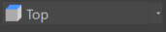 | UCS Named Control | Activates selected UCS (WCS or user-created).

Note: To save a UCS (User Coordinate System), use the Save button in the Axis Tab
You can also control the view using the View Navigator, typically located in the top-right corner of the screen by default.
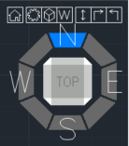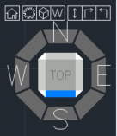

View Control
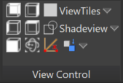
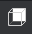 | Back view | Rotates to back view by active UCS.
 | Left view | Rotates to left view by active UCS.
 | Front view | Rotates to front view by active UCS
 | Right view | Rotates to the right view by active UCS.
 | Top view | Rotates to top view by active UCS.
 | ViewTiles | Set multiple view ports.
 | Shadeview | Sets display style (2D, 3D wireframe….).
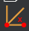 | View by line | Rotates view by drawing a line.
 | Point Cloud Orbit | Rotates the view in 3D space around selected point cloud point
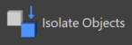 | Isolate Entities | Isolates specified entities.
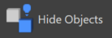 | Hide Entities | Hide selected entities.
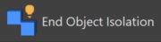 | Deisolate Entities | Deisolates/unhides specified entities.

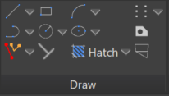
Draw
GstarCAD offers a range of primary and commonly used drawing and editing tools. You can find more detailed information and tutorials on how to use them at GstarCAD Help Center (https://www.gstarcad.net/support/help/ ).
 | Line Tool | Draws straight line segments between two defined points.
 | Polyline Tool | Creates complex shapes with multiple connected line segments, offering high editability and versatility in CAD design.
 | Rectangle Tool | Constructs four-sided polygons with opposite sides equal in length and perpendicular angles, commonly used for representing objects and boundaries in CAD drawings.
 | Circle Tool | Creates perfectly round shapes with a defined radius or diameter, often used to represent curves, holes, or circular objects in CAD drawings.
 | Arc Tool | Generates curved segments of circles or ellipses, allowing users to create arcs and curved shapes in CAD drawings.
 | Ellipse Tool | Constructs elongated or flattened oval shapes representing ellipses, ovals, or elliptical features in CAD drawings.
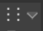 | Multiple Points Tool | Allows users to place multiple individual points at specified locations within a CAD drawing, which can be helpful for various purposes, such as marking coordinates or creating custom patterns.
 | Region Tool | Defines enclosed areas or regions within a CAD drawing, often used for hatching, shading, or highlighting specific sections.
 | Perpendicular Tool | A utility that helps users create lines or objects perpendicular to existing lines or objects in the drawing, ensuring precise alignment and angles.
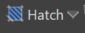 | Hatch Tool | Fills enclosed areas or regions in a CAD drawing with patterns, colours, or textures, enhancing visual representation and distinguishing various elements in the design.
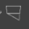 | 2D Solid Tool | Allows users to create filled, two-dimensional shapes with defined boundaries, representing solid objects or areas in CAD drawings.
 | Parallel | Aligns the second specified entity to the first chosen entity.
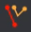 | Polyline aligned | Creates a 2D polyline aligned to the selected object. (Undet tool)

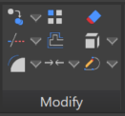
Modify
The Modify Tab in GstarCAD provides various tools to manipulate and modify objects within your drawings. Below is a list of these tools and brief descriptions of their functions. For detailed information and tutorials on using these tools, visit the GstarCAD Help Center (https://www.gstarcad.net/support/help/ ).
 | Copy | Duplicates selected objects and places them in the drawing, allowing for easy replication of elements.
 | Trim | Trims and extends lines and curves interactively by dragging the cursor across the portions to be modified.
 | Fillet | Rounds off the corners of selected objects, creating smooth transitions between lines or curves.
 | Array | Replicates objects in a specified pattern, offering control over the arrangement and distribution of copies.
 | Offset | Creates parallel copies of selected objects at a specified distance, which helps generate concentric shapes.
 | Join | Joins multiple selected lines, arcs, or polylines into a single entity, simplifying complex shapes.
 | Erase | Removes selected objects from the drawing, allowing for efficient cleanup and removal of unwanted elements.
 | Explode | Breaks down complex objects, such as blocks or polylines, into their components for further editing.
 | Polyline Edit | Enables editing of 2D polylines, allowing for adding, deleting, or modifying vertices and segments.

These Modify Tab tools provide essential functionality for editing and refining your drawings in GstarCAD.

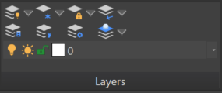
Layers
The Layer Visibility and Management Tools in GstarCAD offer comprehensive control over the layers within your drawing.
These tools help you manage, display, and organize layers efficiently.
 | Layer On | Activates the tool to display all layers in the drawing, making objects on all layers visible.
 | Layer Off | Activates the tool to hide selected layers in the drawing, making objects on those layers invisible.
 | Layer Properties Manager | Opens the Layer Properties Manager, providing a central hub for managing layer properties, settings, and organization.
 | Freeze Layers | Activates the tool to freeze selected layers, preventing objects on those layers from being displayed or edited.
 | Thaw All Layers | Activates the tool to thaw all frozen layers in the drawing, allowing objects on those layers to be visible again.
 | Layer Walk | Displays objects on selected layers and hides objects on all other layers
 | Lock Layer | Activates the tool to lock selected layers, preventing any object changes on those layers.
 | Unlock Layer | Activates the tool to unlock previously locked layers, allowing you to modify objects on those layers.
 | Isolate Layer | Activates the tool to isolate selected layers, making only the objects on those layers visible and others hidden.
 | Deisolate Layer | Activates the tool to deisolate previously isolated layers, restoring the visibility of all layers.
 | Make Object’s Layer Current | Sets the current layer to that of a selected object
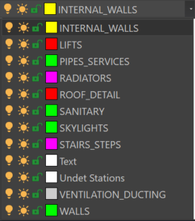 |  | Dropdown Layer Manager menu  Provides access to a dropdown menu with additional layer management options, enhancing layer organization.  These Layer Tools provide essential functionality for managing and organizing layers in GstarCAD, helping you maintain a structured and efficient drawing environment.  For more detailed information and tutorials on using these tools, refer to the GstarCAD Help Center.

Tools
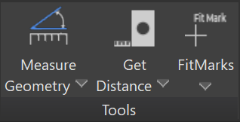
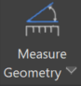 | Measure Geometry | Can measure the Angle, Area, Distance or Radius of selected geometry.
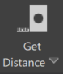 | Get Distance | Get Distance, Area, Coordinates, Properties or Region/Mass Properties
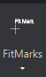 | FitMarks | Creates FitMarks and writes down its coordinates
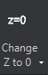 | Change Z to 0 | Changes selected objects’ Z coordinates and elevation of polylines to 0.
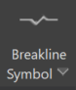 | Break Line | Creates a break line by specifying two side points and a middle point for a break
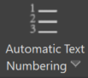 | Automatic Text Numbering | Use this command to insert sequential numbering to selected text entities.
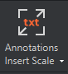 | Annotation Insert Scale | Changes Undet Browser annotations insert scale (default value 2).
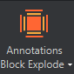 | Annotations Block Explode | Explodes block of Undet Browser annotations into solid text.

Help
User Guide: opens GstarCAD Point Cloud User Manual
About: access detailed information about your license and activation.

Undet Indexer Project Creation Tutorial
Undet database has double-file structure Preview points and Full points. Selecting the right project type speeds up the indexing process, without losing full point cloud points and affects only the preview view. Preview points are creating from all imported scan data by using GRID, which size depends on the selected project type. The default GRID size for each project is chosen for optimal indexing speed and faster preview navigation to find a place to load all points using the “clipping box or view section”.

Undet loads all points in the “clipping box or view section” when point count is less maximum point count. The maximum point count can be set manually in each Undet solution according to your system hardware parameters. If your clipping box is too big to load all points you will see only preview points.

Select project type based on your scan data set
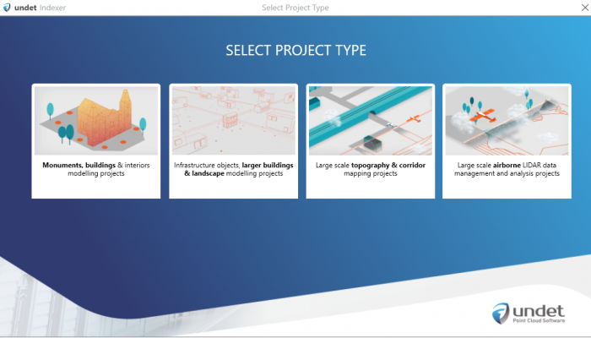

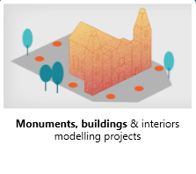 | Monuments, buildings & interiors modelling projects (The most common choice for small detailed objects such as monuments, parts of buildings or areas with a footprint up to 100m²)
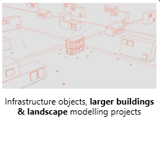 | Infrastructure objects, larger buildings & landscape modelling projects (The most common choice for terrestrial scanners)
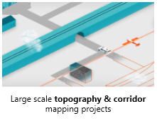 | Large scale topography & corridor mapping projects (The most common choice for infrastructure projects)
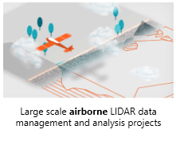 | Large scale airborne LIDAR data management and analysis projects (The most common choice for large airborne LiDAR projects)

Note: Selecting the right project type speeds up the indexing process, without losing full point cloud points and affects only the preview view.

Default “max point count” settings of Undet product:
GstarCAD: Interval from 8 – 24 million points [can be tuned with performance slider]

Examples with different project GRID
Large scale airborne LIDAR data management and analysis projects
Preview points | All points loaded with clipping box (view section)
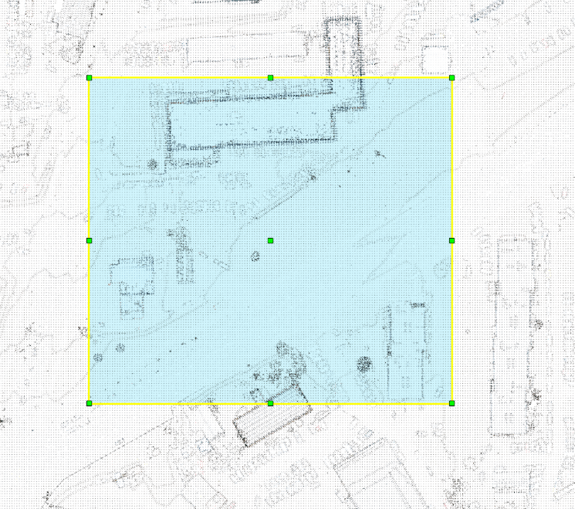 | 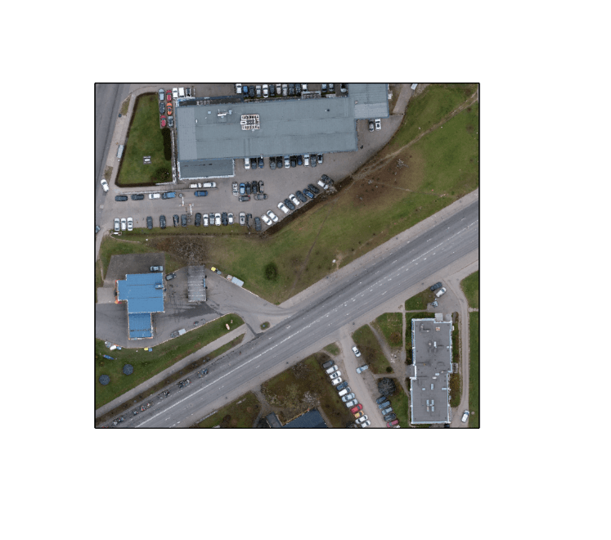
Large scale topography & corridor mapping projects
Preview points | All points loaded with clipping box (view section)
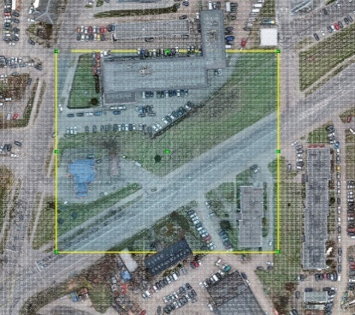 | 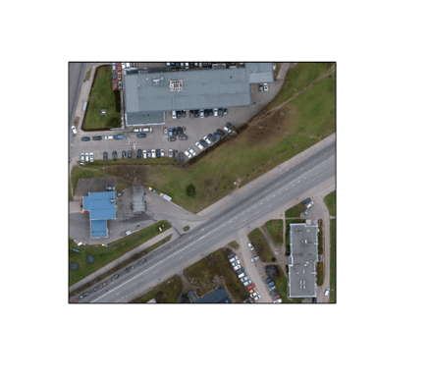

Infrastructure objects, larger buildings & landscape modelling projects
Preview points | All points loaded with clipping box (view section)
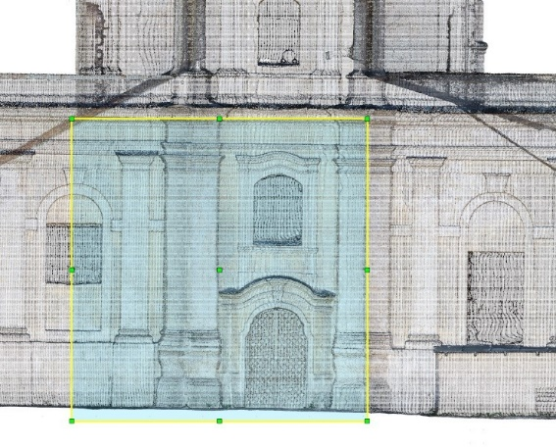 | 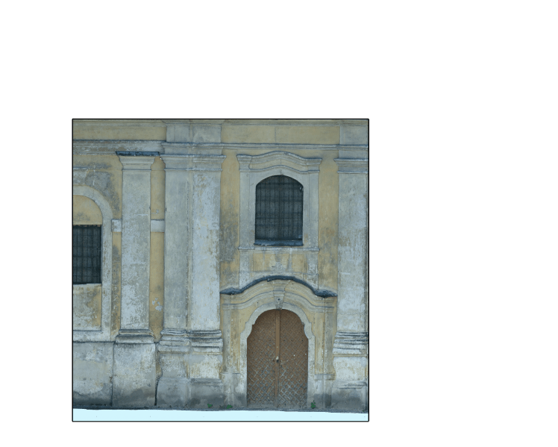
Monuments, buildings & interiors modelling projects
Preview points | All points loaded with clipping box (view section)
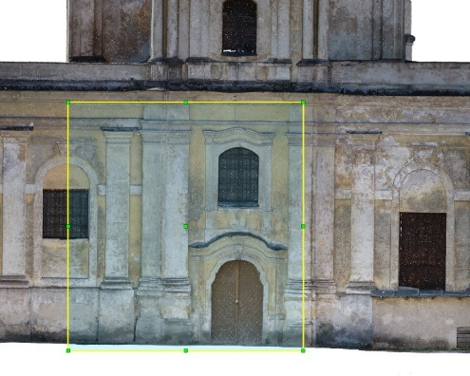 | 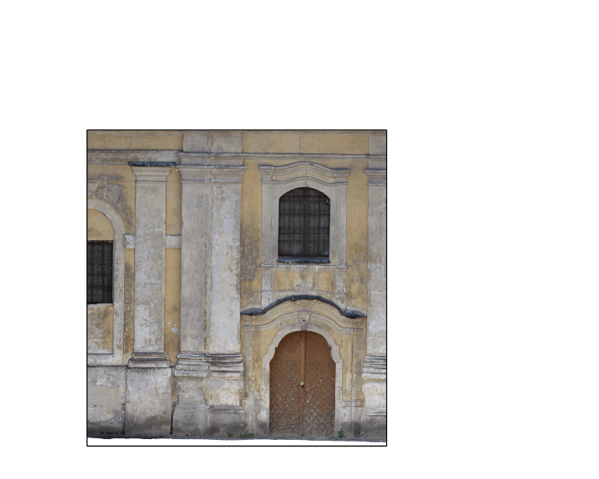
Zoomed view (Preview points) | Zoomed view (All points loaded with clipping box)
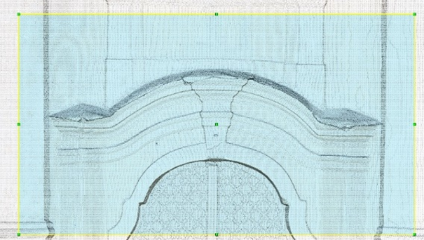 | 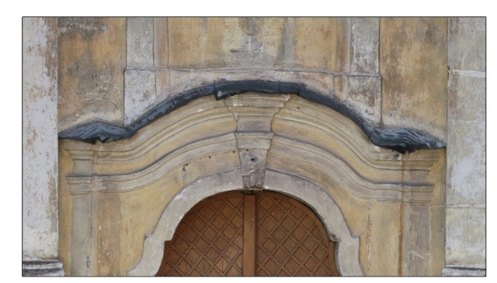

Scan data file import
To create Undet project you need to import scan data files from your local pc or network drive.
Supported formats: *.E57, *.RCP/RCS, *.PLY, *.FLS, *.ZFS, *.LAS, *.LAZ, *.PTS, *.PTX, *.DP, *.FPR, *.LSPROJ, *.FWS, *.CL3, *.CLR, *.RSP, ASCII / NEZ (X,Y,Z/i/RGB) and custom ASCII / TXT file format import.
Import scan data press [Add Files] action button and select your point cloud data files.

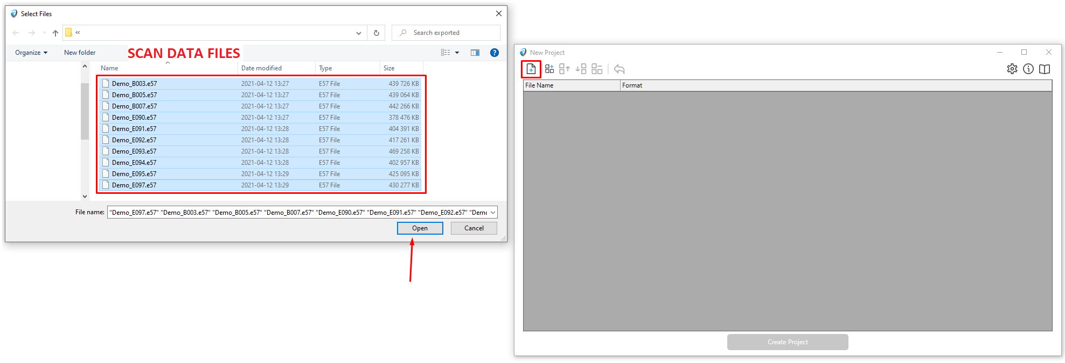
Note:
- You can mix different file formats to create a single project (as for an example: Terrestrial scan data *.e57 files and UAV roof data *.LAS file format.). Just all scan data files should be registered and on the same scale and coordinate system.
- Undet keeps initial point cloud structure and dimensions (scale).
- If you are indexing scan data files in large / state coordinate system (as an example UAV, Airborne LiDAR) in all Undet plugins, there are “coordinate system transformation” tools.

Grouping
Imported scan data files can be grouped into logical groups (inside, outside, 1st floor…), using [Create Group] action button.
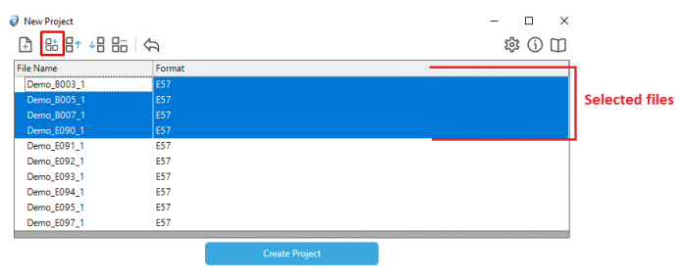
The created group can be renamed at any time. Later on, you will be able to manage visibility for each group with a single click (As an example: if you want to get clear building elevation view you need to disable inside scans)
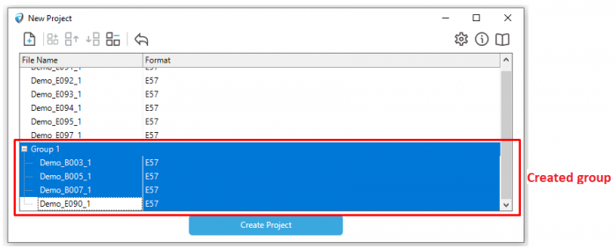
Note: You can skip the grouping step because you will be able to group or regroup data files in already created Undet project when it is loaded into one of our Undet solutions.

Create Undet project
When all scan data files are imported. Click [Create Project] action button to start the indexing project.
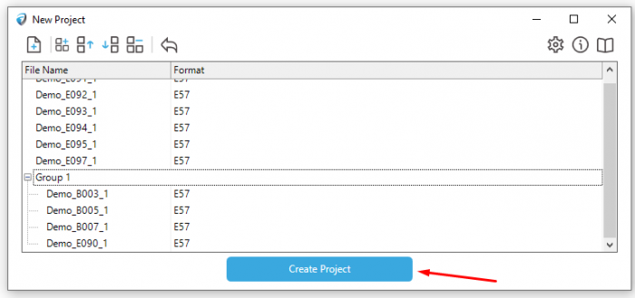
Once [Create Project] action button clicked you need to accept to Undet Project settings (selection by default it’s recommended).
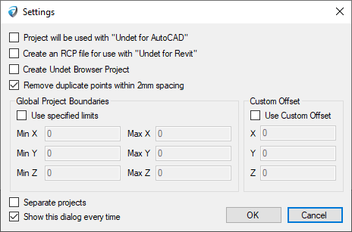
Project will be used with “Undet for AutoCAD” | This option is only required when the project will be used with Undet for AutoCAD software, additional files are created for the project and the indexing process takes a little longer. We recommend to take this option off if you are not using Undet for AutoCAD.
Create an RCP file for use with “Undet for Revit” | This option is only necessary when the project will be used with Undet for Revit software. An additional RCP file is created for the project, and the indexing process takes longer. We recommend turning off this option if you are not using Undet for Revit.
Create Undet Browser Project | This option required when you are planning to use our Undet Browser solution. It required on to create panoramic images and the indexing process takes a little longer. Undet Browser works as a 3D panoramic image viewer and connects 3D point cloud files from an Undet project with the CAD model space via Undet plug-ins. Learn more.
Remove duplicate points within 2mm spacing | This is an additional option to filter out very dense points (duplicates in 2mm 3D distance), which is necessary to create 3D models, or 2D drawings in scale 1:200-1:50. We strongly recommend using this function. Example below.
Use specified limits | Some time is necessary to use a project clipping box (project area boundaries) to eliminate noise points or create an Undet project only in the required location.  In “Global Project Boundaries” if you need you can insert your project MIN – MAX meanings for each coordinate.  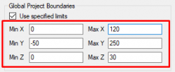
Custom Offset | Allows users to manually adjust the positioning or alignment of the point cloud data according to their specific requirements within a given coordinate system. This feature is useful for precise alignment with other models or reference points and compensating for variations in data acquisition or registration.  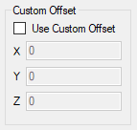
Separate projects | Creates point cloud files from choosen files separately.
Show this dialog every time | To show advanced settings dialog every time while creating Undet project.

Remove duplicate points within 2mm spacing example:
As an example, a terrestrial laser scanner is collecting very dense points near the scan station. Basically, you don’t these points. Lighter point cloud – smoother performance.
Data with 2mm filtering  (Total point count: 18 863 247) | Data without 2mm filtering  (Total point count: 42 947 892)
Top view | Top view
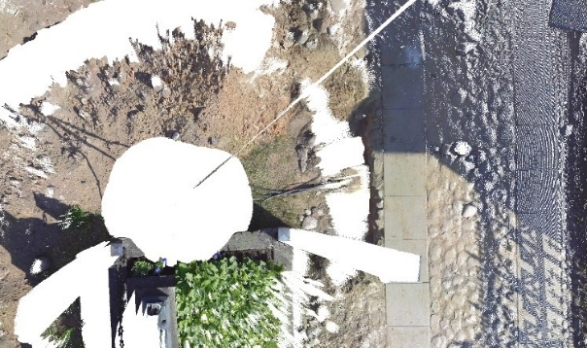 | 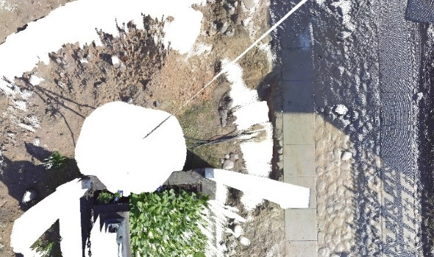
Side view (5 meters away) | Side view (5 meters away)
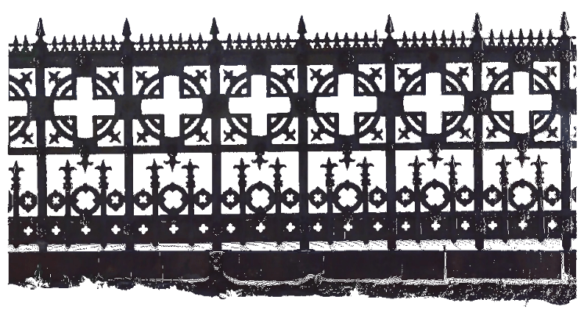 | 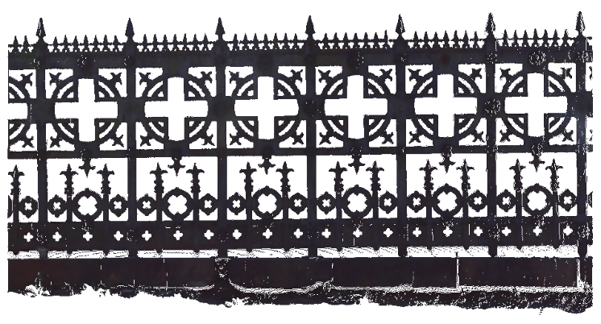
Project size: 0.55 GB | Project size: 1.07 GB

Global Project Boundaries example:
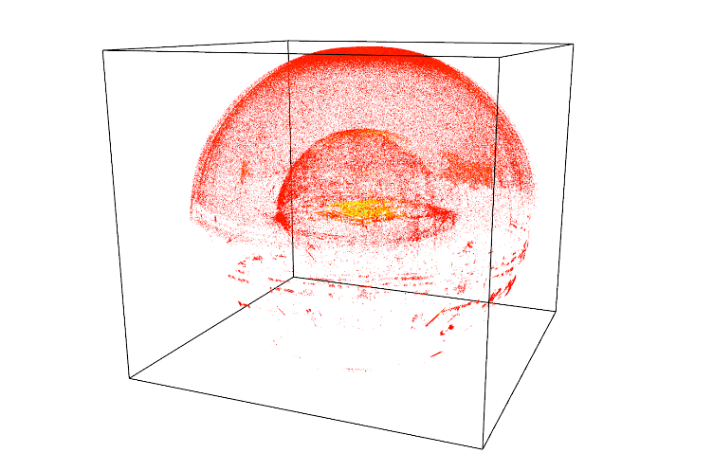 | 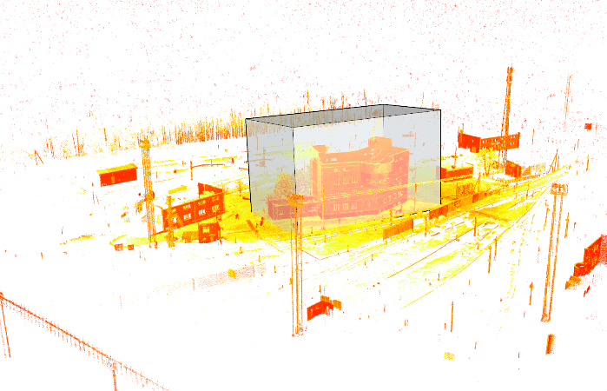
Undet project created without project clipping box (all data) | Undet project created without project clipping box (all data).
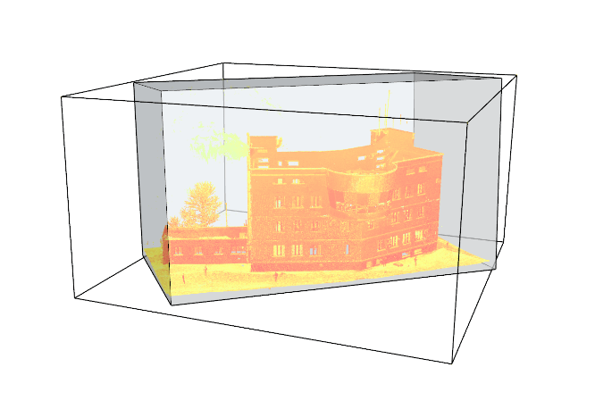 | 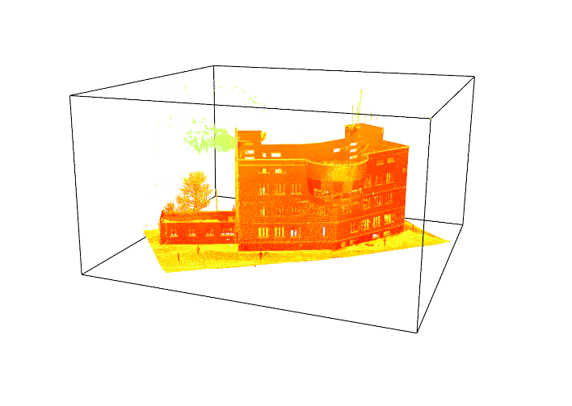
Silver box is clipping area to create Undet project. | Undet project created using global project boundaries feature.

Additional feature available to import and index random TXT formats:
To import not structured TXT point cloud data files, you can manually set file data format. Clicking in format column on the selected file “Add…”
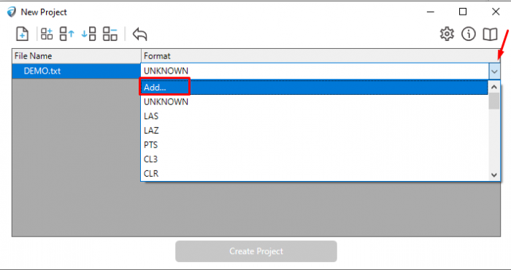
In the next dialog, you will need to select data file: separators and column fields for column values: X, Y, Z, R, G, B, and intensity.
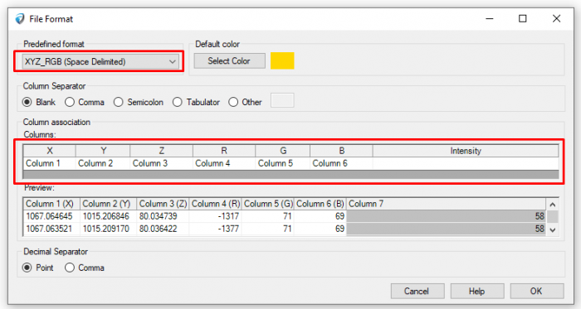
Check disk space feature (while indexing)
To create Undet project you need triple (3x) size on your HARD DRIVE according to your scan data file size. As an example: scan data files size (20 pcs. of *. e57 files 10GB), so you will need 30GB free disk space.
If you have enough disk space for project creation, please disable the “check disk space” option and the indexing process will be much faster.
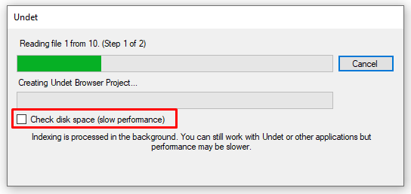
Otherwise, with enabled “check disk space” function, software during the indexing process will inform you that you don’t have enough disk space and you will be able to free up disk space and continue the indexing process.
Please note that this strongly slows down the indexing process.
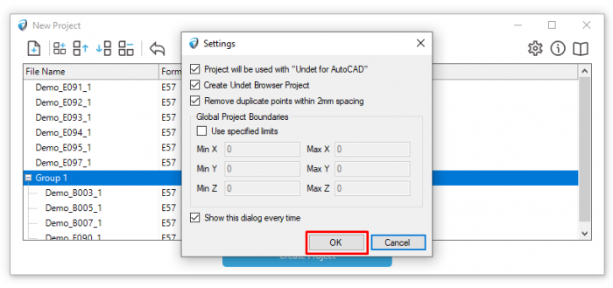
After Undet Project settings accepted you will need to locate where to save the Undet project.
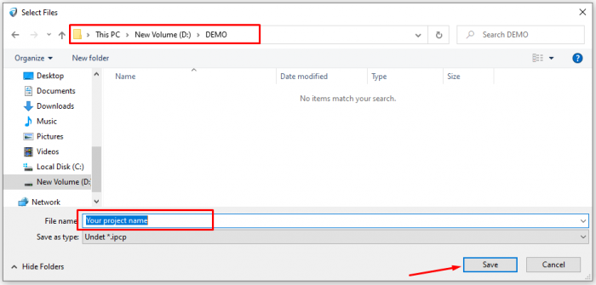

Note:
- Undet does not support Unicode characters (@#$%!^&*абвдгж…) in path and in project name, please avoid these symbols.
- The indexing process may take couple minutes or a couple of hours to proceed, it depends on project type and amount of scan data files size.
- To create Undet project you need triple size on your HARD DRIVE according to your scan data file size. As an example: scan data files size (20 pcs. of *. e57 files 10GB), so you will need 30GB free disk space.

Created Undet project
When the project is successfully created in your selected location you will find IPCP file with the same name folder. These files are Undet project and should be kept together.
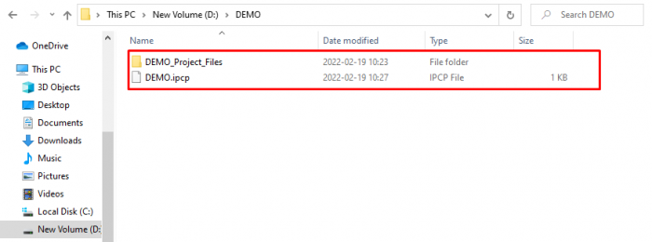
Note:
- The project name can’t be changed using “rename” function.
- Undet does not support Unicode characters (@#$%!^&*абвдгж…) in path and in project name, please avoid these symbols

Any problems while creating Undet project, please go to: https://www.undet.com/contact-us/

Undet Brower with GstarCAD
Undet Browser is a free stand-alone point cloud viewer explicitly created to help you view, analyze and navigate your digital data as a panoramic view. This will help you better and more quickly understand your scan data and share it with colleagues and customers.
Undet Browser solves the main problem where it is not always easy to view and understand the point cloud in a CAD model and where you often have to look at another screen loaded with a particular point cloud viewer. Most point cloud viewers work as separate software. Undet point cloud viewer works quite differently and offers unique features when point cloud viewer and Undet plugins are synchronized.

Create an Undet Browser Project
To create an Undet point cloud project compatible with Undet Browser, check the “Create Undet Browser Project” option in Undet Indexer settings. This option enables the creation of an Undet Browser project associated with your point cloud data, enhancing your ability to view, analyse, and navigate your data in panoramic views.
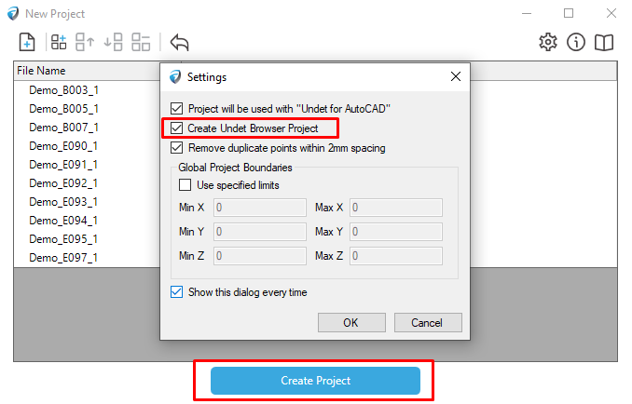
Technical requirements for your point clouds to use Undet Browser:
- Point cloud data must be structured with scan station center information.
- Supported file formats: *.E57, *.IPCP, *.FLS, *.ZFS, *.RCP, *.PTX
- Unstructured and not supported point cloud file formats: LAS, *.LAZ, *.PTS, *.PLY, *.DP, *.ASCII, *.TXT, *.XYZ.

Undet Browser features for GstarCAD
First, to use all Undet Browser features, we must activate Scan Positions markers (BB) in the Scan Data Manager.
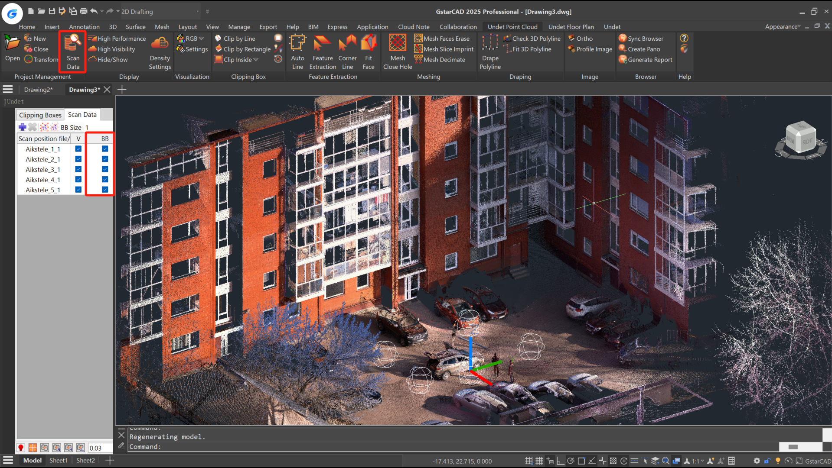
- Open Undet Browser using Scan Positions markers (BB)
Double-clicking the Scanning Station Sphere (markers) will open the Undet Browser.
In the GstarCAD model space, locate the scanning station symbol, represented as a sphere. Double-click the left mouse button on the center symbol of the scanning station (the sphere) to open the Undet Browser with the selected position view.
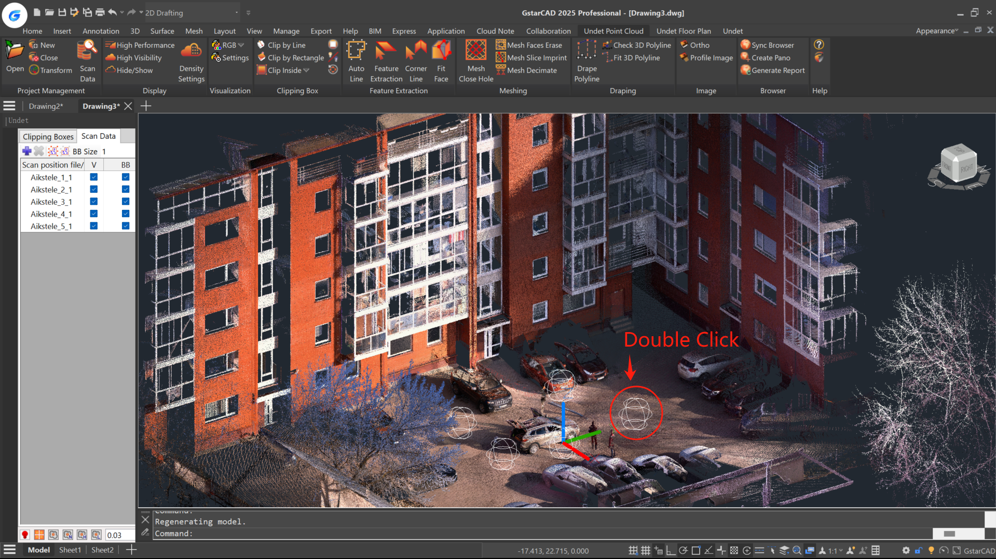
- Sync Browser (View Sync) feature
This feature allows you to orientate the view from the nearest scan stations in Undet Browser to an unclear view of a point cloud slice with a single click.
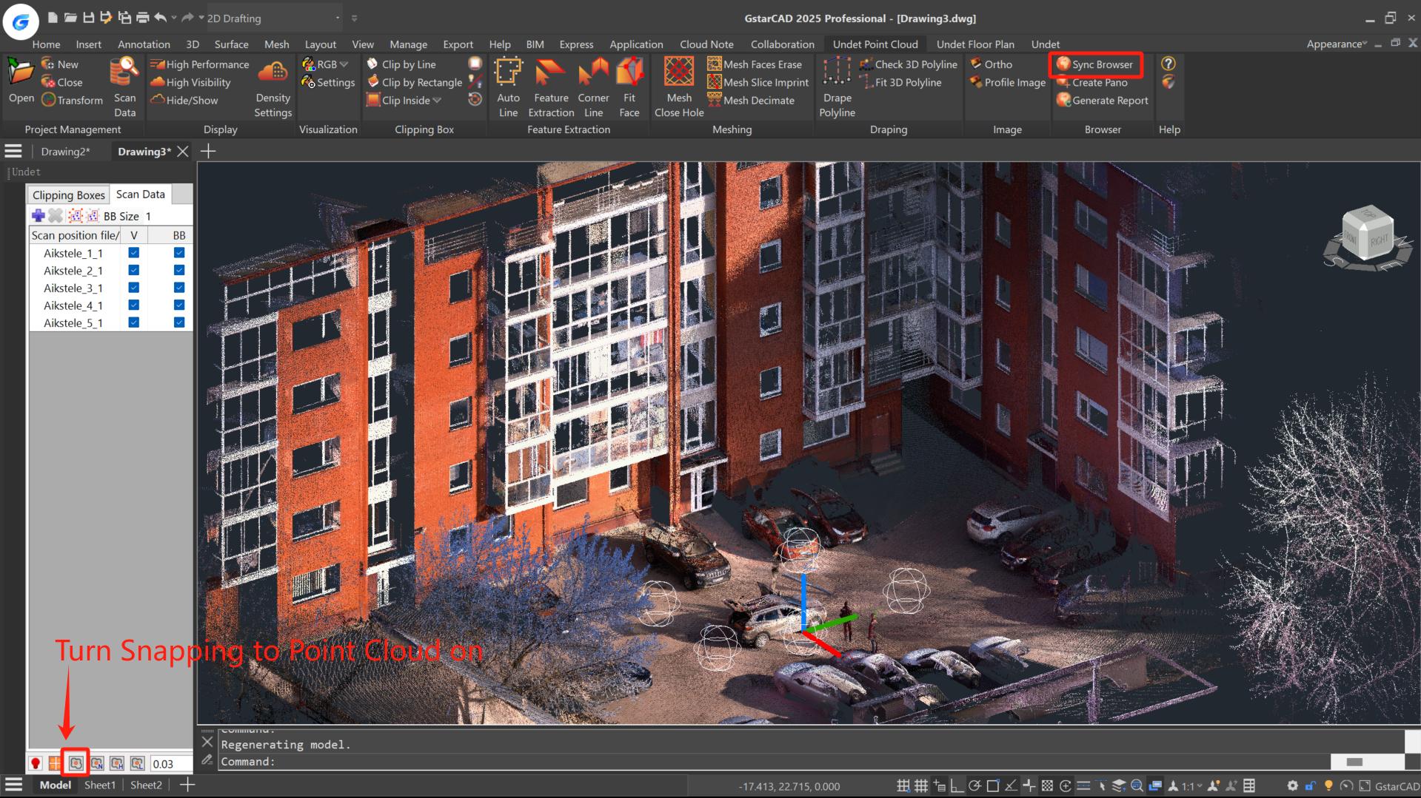
Press the [Sync Browser] button in the GstarCAD model space and select a point cloud point from your model space by picking it. Don’t forget to turn snap to point cloud points on.

The [Sync Browser] tool will locate the scan station view in the Undet Browser based on the point cloud point you picked. As a result of selecting the point cloud point, you will get the nearest scan station panoramic views oriented to the area around your selected point.
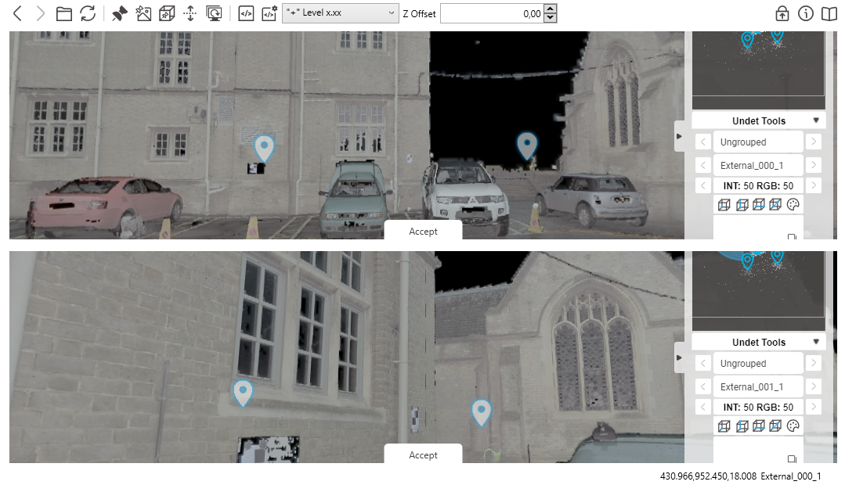
By pressing [Accept], you can choose the most relevant view from the available options.
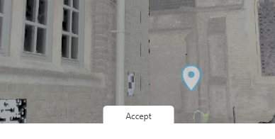

- Draw points feature
This feature allows you to send a 3D point to the CAD model by picking a point in Undet Browser view.
- Activate the Draw Points function
- Pick a point in Undet Browser
- A 3D point is automatically inserted into the CAD Model as the picked point location through Undet Browser.
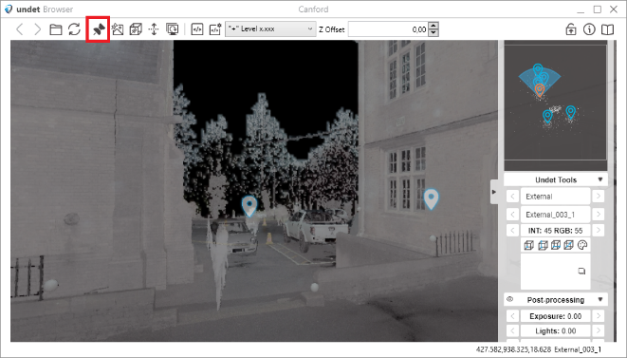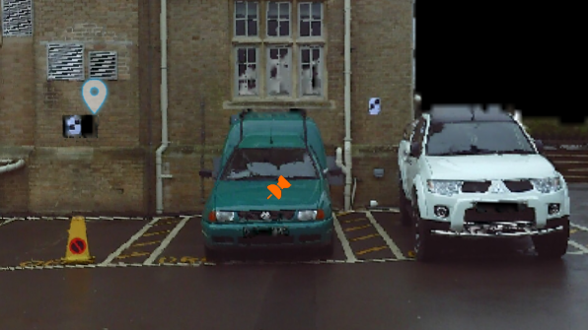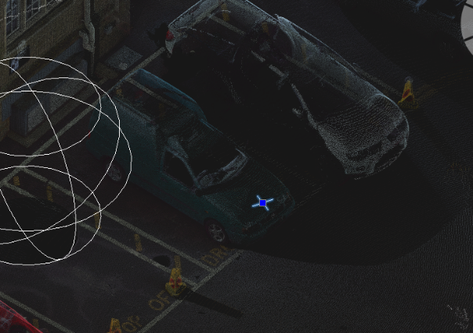

- Add Href feature (available only with FARO SCENE Webshare Cloud service account)
This feature allows you to add a hyperlink to a screenshot of the panoramic scan view for the selected point.
  - Activate Add Hrefs (Draw Points need to be active).
  - Pick a point in Undet Browser.
  - Select your picked point in the GstarCAD model and turn on properties – you will find a Hyperlink to a saved screenshot of a panoramic view.
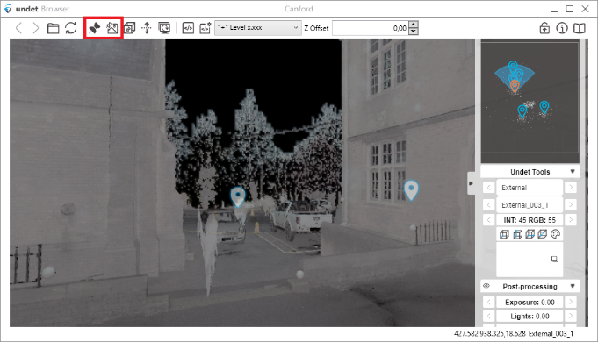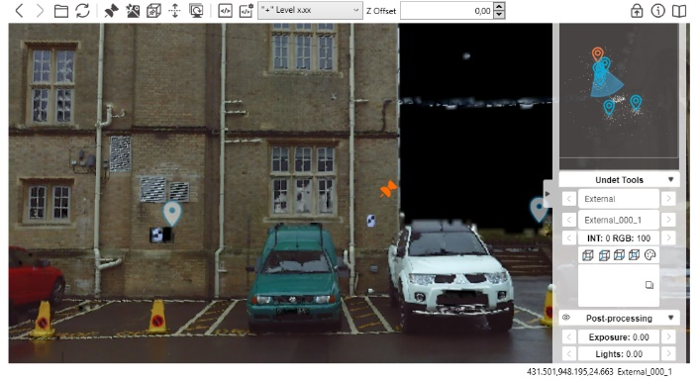

- Translate View Section
This feature allows you to shift/translate the Undet Clipping Box location by clicking in the Under Browser scan view.
  - Create a Clipping Box in the GstarCAD model.
NOTE: This feature shifts/translates the center of the active point cloud slice regardless of its size or thickness.
  - Activate [Translate View Section] in Undet Browser and pick a point in panoramic view to update your Clipping Box location.
  - As a result, your clipping box center will move to your picked point.
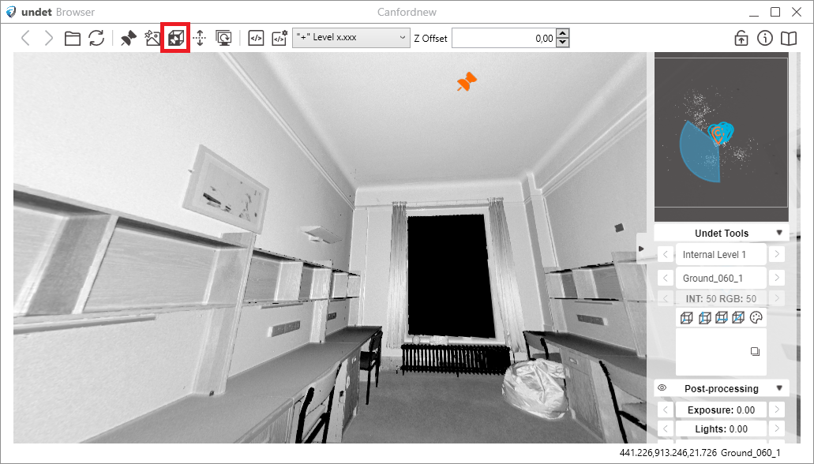

- Change Elevation feature
This feature allows you to set the Z value for newly created CAD objects.
NOTE: To reset the Z value back to its default value of 0, use the ELEVATION command in GstarCAD and set it to 0.

For example: Polyline drawn with Change Elevation function turned off Z value – 0. Activate Change Elevation and pick a point in Undet Browser for Z elevation. Polyline Drawn with Change Elevation will have a Z value of the picked point.
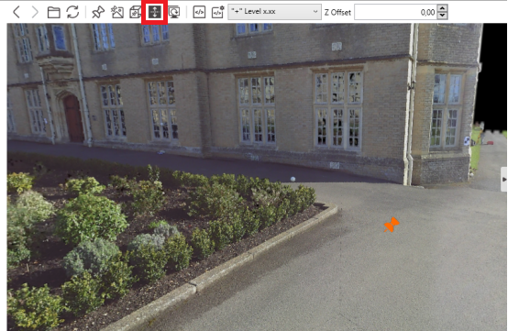

- Scripts feature
This feature simplifies annotation by providing access to a comprehensive library of over 50 pre-built scripts. These scripts empower users to streamline and enhance their workflow when working with point cloud data. Whether you need to label specific features, apply measurements, or execute custom actions, Undet Browser Scripts offers many options for precise and efficient data manipulation. Detail Undet Browser Scripts Tutorial: https://youtu.be/Wn5fhnwGpNs?si=FClzPXoOjpP0p_1x
NOTE: Undet Browser Scripts are not limited to the existing set. Users can write custom scripts, tailoring the tool to their unique project needs. This flexibility opens up a world of possibilities for users seeking to optimize their point cloud data analysis, annotation, and interpretation.
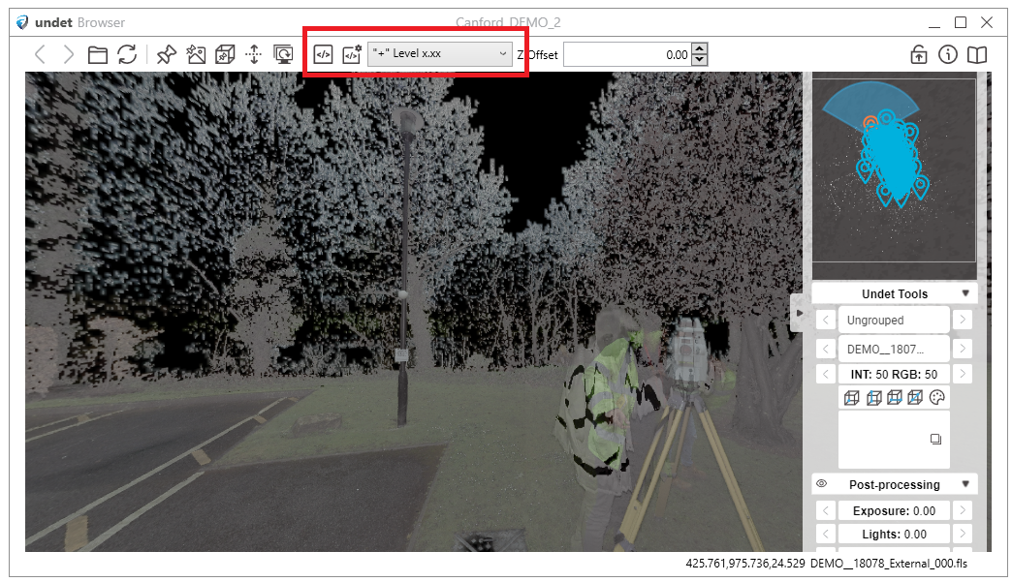
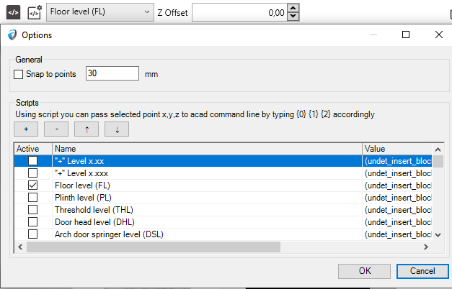

- Offset feature
This feature allows you to set reference Z-level.
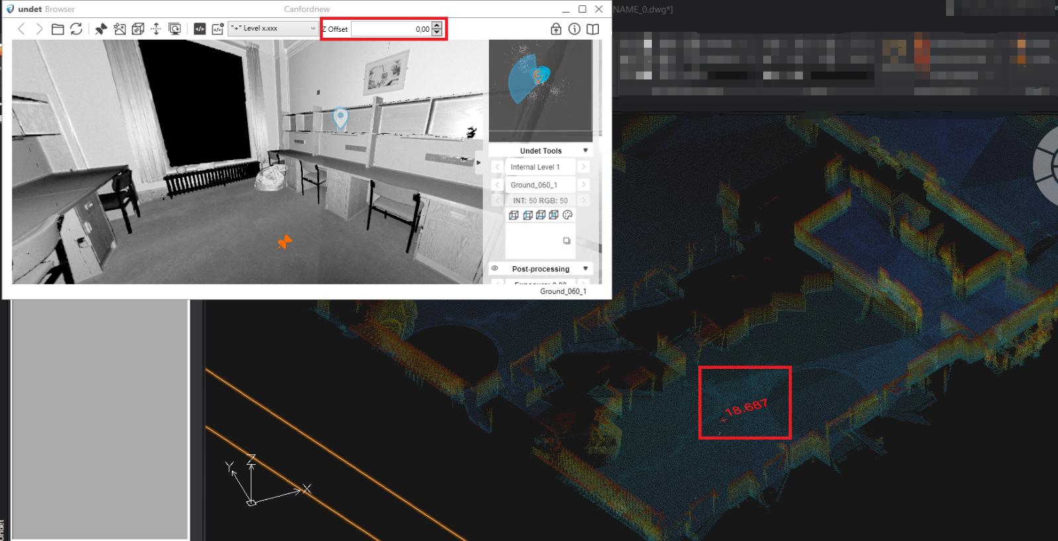
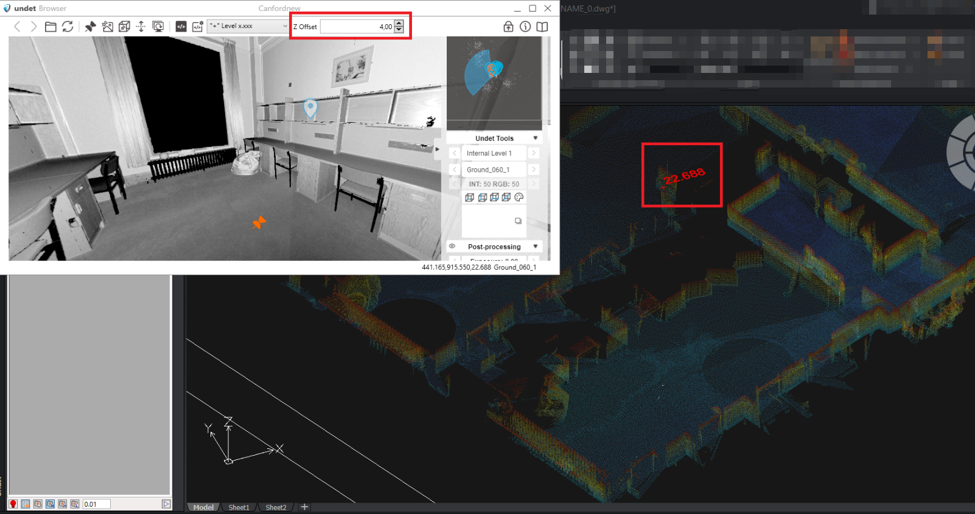

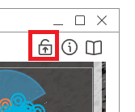
- Always on top feature
This feature ensures the Undet Browser window stays visible above other programs, allowing easy access while working with GstarCAD or any application, preventing it from getting hidden in the background.
NOTE: For the most efficient work, we recommend using two screens: one for CAD and another for Undet Browser.

