

Registration Process
Please follow the steps below to register the GstarCAD 365 Account:
- Access GstarCAD 365 official website through browser:https://enweb.gstarcad.net/gstarcad365/
- After opening the official website, click Sign Up in the upper right corner to enter the Registration Interface.
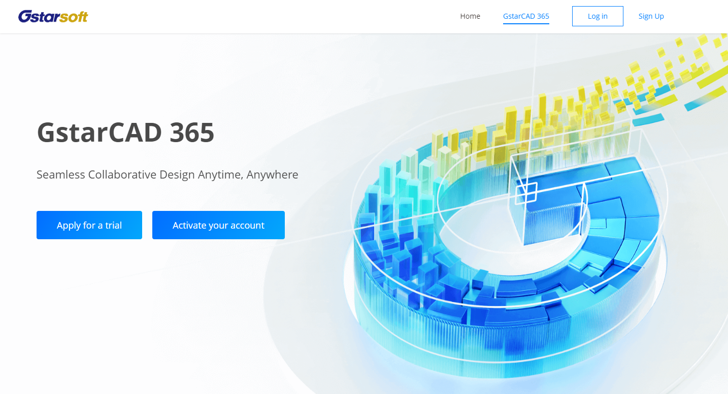
- Enter your registration information.
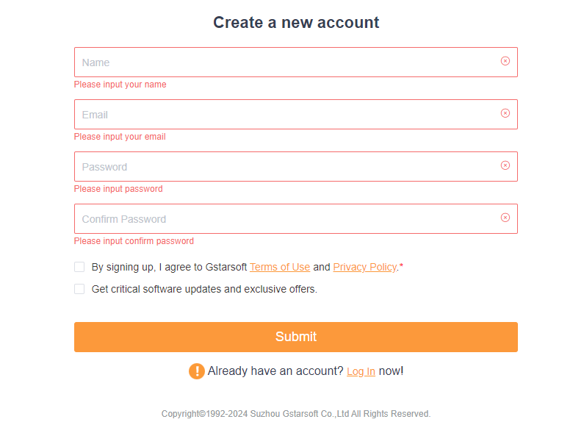

- Read and check the "Terms of Use" and "Privacy Policy".
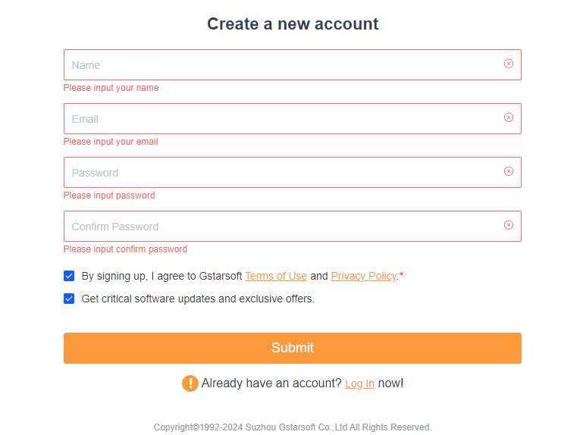
- Click Submit to finish the registration.
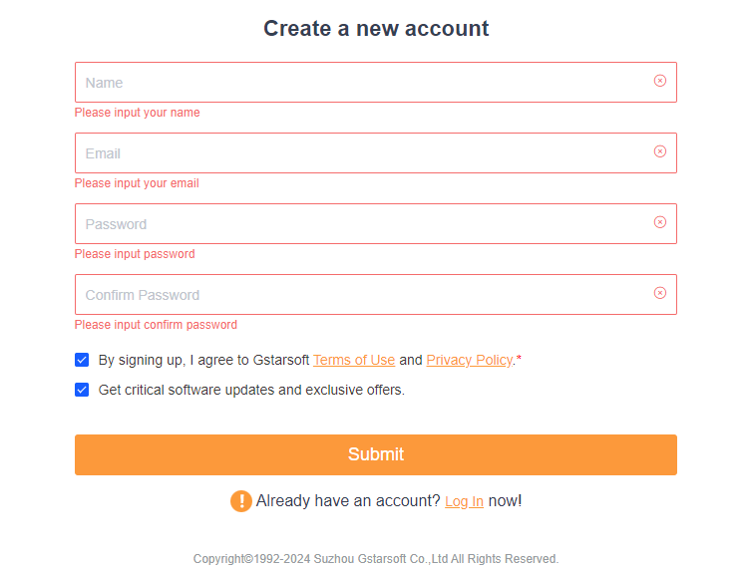

Activate Your GstarCAD 365 Account
Please follow the steps below to activate your GstarCAD 365 Account:
- Access GstarCAD 365 official website through browser: https://enweb.gstarcad.net/gstarcad365/
- Click Activate your account to enter the Management Backend interface. The GstarCAD 365 Company Management Backend is a web-based tool designed to help company manage projects, personnel, drawings, and permissions.
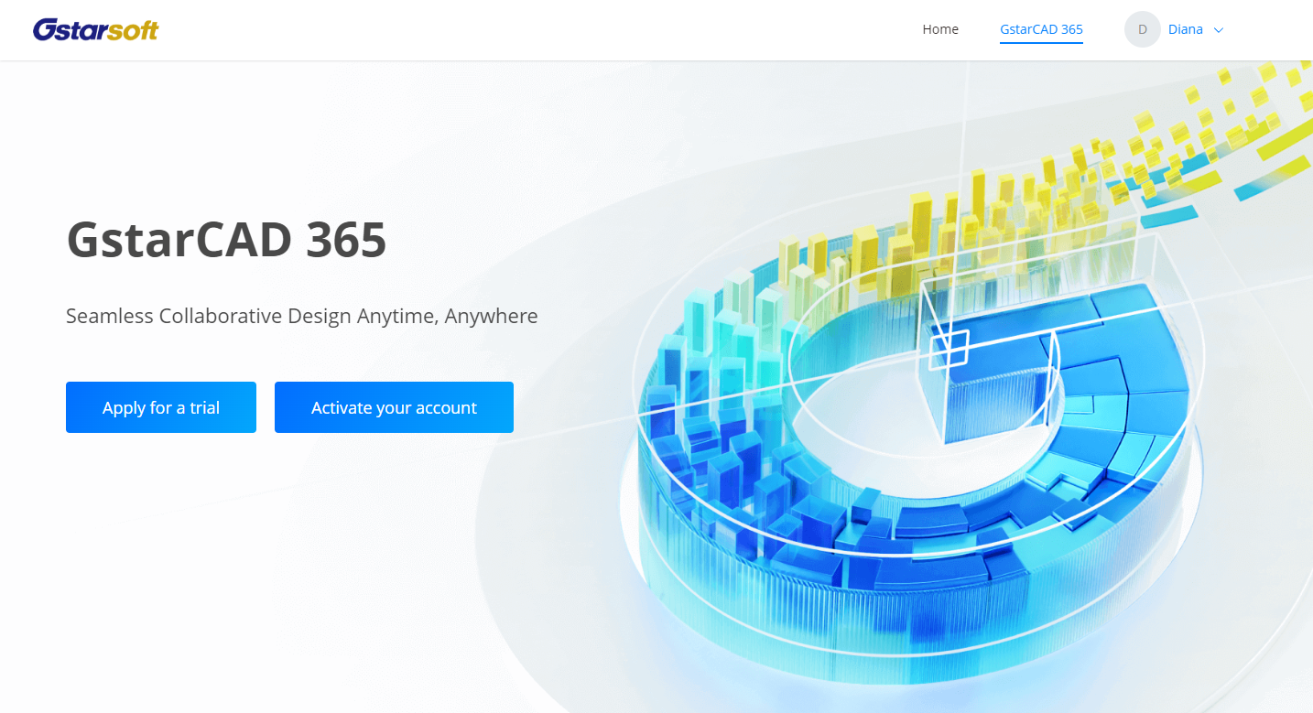
- Please input the Activation Code where you can purchase from your local GstarCAD distributor/reseller.
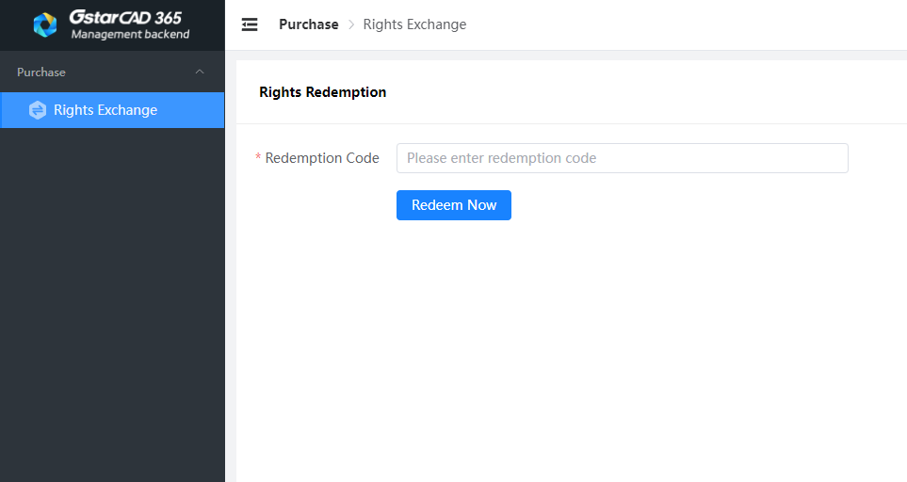
Please input your Activation Code here.
- Click “Redeem Now” to successfully activate. Then you can use the the Management backend to add members, allocate rights, create projects, upload drawings, and set permissions.
***********
Remark: Both administrators and regular employees within the company can log in to the GstarCAD 365 Company Management Backend. However, the available features are determined by the user's company permissions, resulting in different access levels and functionalities. Throughout the project lifecycle, company administrators can utilize the backend to manage various data assets and monitor employee activities systematically.

Download Applications
Access the GstarCAD 365 official website through the browser: https://enweb.gstarcad.net/gstarcad365/
With cross-platform account system, GstarCAD 365 allows users to access CAD drawings and start their designs from a specific platform.
Download GstarCAD 365 Applications:
After accessing the GstarCAD 365 official website, scroll down to the Client Download section, click the Download button of the corresponding clients to download according to your need.

