

Table of Contents
1. Gstarsoft Network License Manager (GNLM) Installation and Option Settings 1
1.1. Installation 1
1.2. Configuration Settings 2
2. Gstarsoft Network License Manager Interface 3
2.1. General Settings 3
2.2. Network License Manager Dialog Box 4
2.2.1. Real-time Authorization Data 5
2.2.2. Authorization Data Statistics 5
2.2.3. License Management 8
2.2.4. Permission Settings 9
2.2.5. Permission Assignment 11
2.2.6. Reserved Nodes 11
2.2.7. Timeout Settings 12
2.2.8. Troubleshooting 12
2.3. Other Settings 13
2.3.1. Adjust Gstarsoft Network License Service 13
2.3.2. GstarCAD Network License Service Version information 13
2.3.3. Quit GstarCAD Network License Manager 13
2.4. Uninstall 14

Gstarsoft Network License Manager Guide

The GstarCAD Network License encryption mode enables you to share multiple GstarCAD licenses on your office LAN, providing flexibility for license floating among a working group. Before the network installation, you should specify the server computer where Gstarsoft Network License Manager will be installed.
Gstarsoft Network License Manager (GNLM) is a centralized network license management platform developed by GstarCAD Software. It supports data management on Windows platform. This tool provides core functions such as real-time monitoring, multi-dimensional data analysis, refined permission control, and intelligent trouble shooting, enabling visual management of CAD licenses and resource optimization configuration.

Gstarsoft Network License Manager (GNLM) Installation and Option Settings

Installation
Please follow the steps below to install and set the configurations:
Double click "GNLM_Setup.exe" to install Gstarsoft Network license Manager.
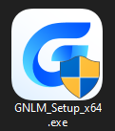

You can click Yes to continue the installation.
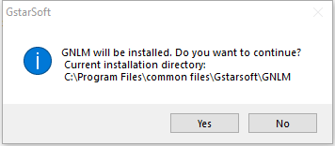

You can choose whether start the server immediately or start it later.
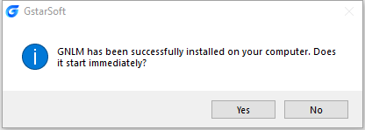

You will find a tray icon with exclamation mark shown in the taskbar after installation has been completed. And there will be a tip like “Service is not found. Please check your settings” before you set the configurations.
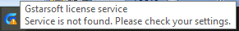

Configuration Settings
After the Gstarsoft Network License Manager is installed, click the Gstarsoft Network License Manager icon and click Options to set the configurations.
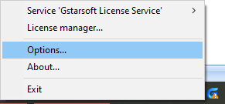

Set the configurations as below:
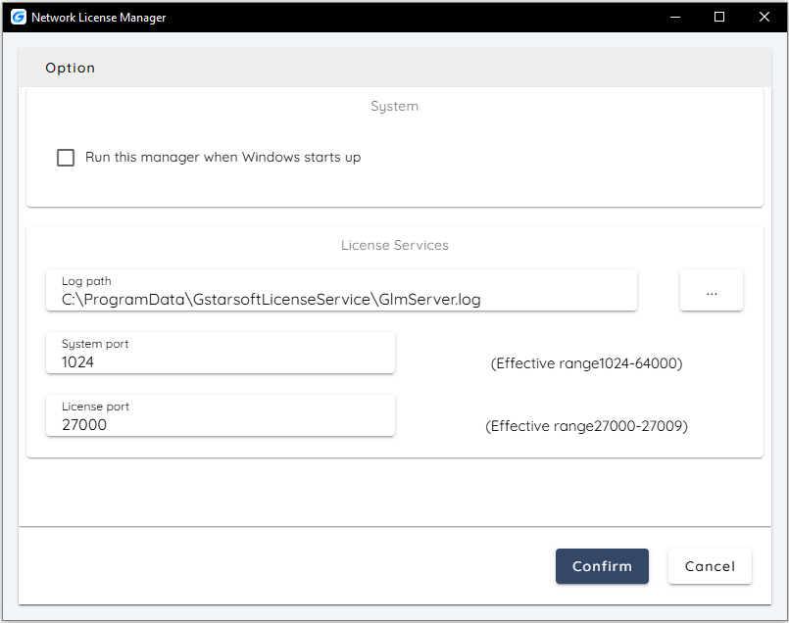

- System:
Run this manager when Windows startup: When this option is checked, the Gstarsoft Network License Manager can be run automatically when Windows starts.
Remark: "Run this manager when Windows startup" option will not affect the license status.
- License service:
Log Path: You can specify a path to save the license logs and the path should allow LocalService to write in, otherwise the license service will fail to run. If your operation system is Windows 10, the default path ProgramData is recommended.
System port: The valid range should among 1024-64000.
License Port: The valid range should among 27000-27009.

After the configurations have been confirmed, the exclamation mark will change to check mark.

Gstarsoft Network License Manager Interface
Click Gstarsoft License Service icon and select License Manager option to load Network license manager box.

General Settings
To ensure that user permissions can be set smoothly, the following operations must be completed before managing the network license permission. Click Settings button in the up-right of the interface.
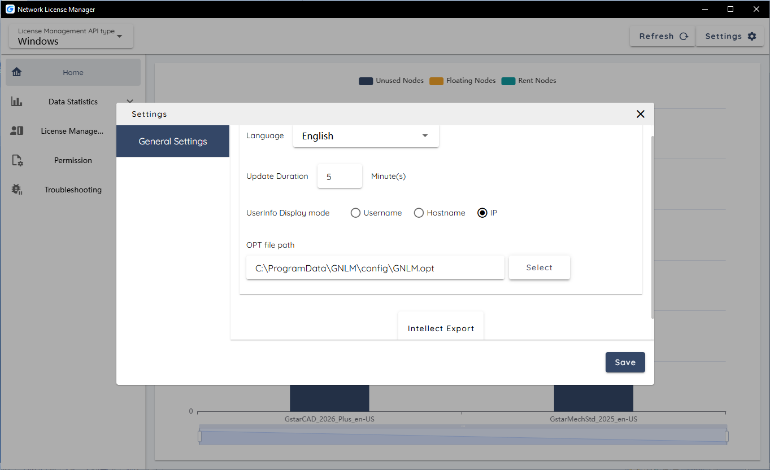

Language: English/Chinese (the default is based on the user's system language).
Note: After adjusting the language settings, if you need to switch back to the default language, you need to manually set it.
Update Duration: Customize the interval for NLAT to read data from the server. The default is 10 minutes, the minimum is 1 minute, and the maximum is 2147483647 minutes.
User Information Display Mode: Control the mode in which user information is displayed on the permission setting page. The default mode is user name.
OPT File Path: If you need to set up user authorization number permissions, reserve nodes, and other settings, enter the correct OPT file path, otherwise you do not need to fill in the information.
Intelligent Export: Through in-depth analysis of user operation habits, the following key indicators are intelligently generated to provide data support for authorized resource management and procurement decisions. Key indicators include: total number of users, daily usage peak, average usage peak, average number of days of user use, and average user usage time.
Note: This function is not yet fully complete, please wait for subsequent version updates.

Network License Manager Dialog Box
The functions of the GNLM tool are divided into five major categories: Home, Data Statistics, License Management, Permission, and Troubleshooting. For details, please refer to the tabs on the left side of the tool interface.
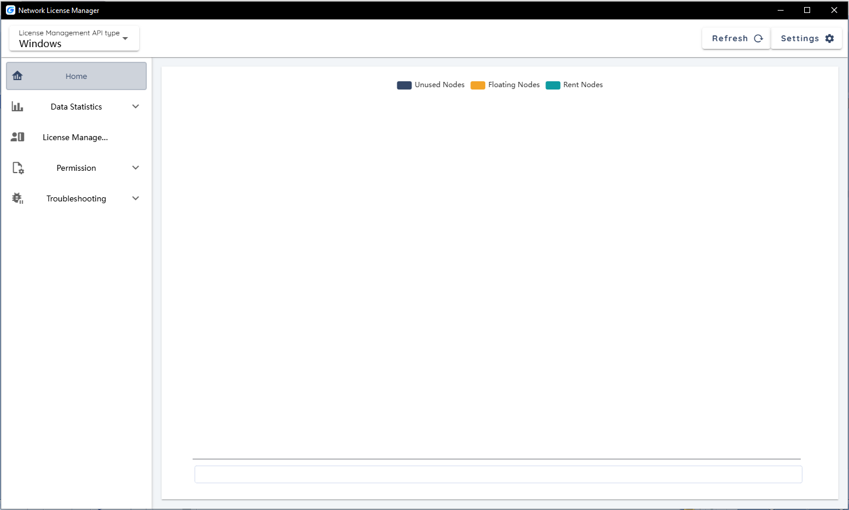

Real-time Authorization Data
When GNLM is started, the system will automatically start reading data from the authorization server and display the information on the Home interface.
You can see the usage of the authorization number at the current time point. When the mouse is placed on the bar data, specific information will be displayed, including "Unused Nodes", "Floating Nodes" and "Rent Nodes".
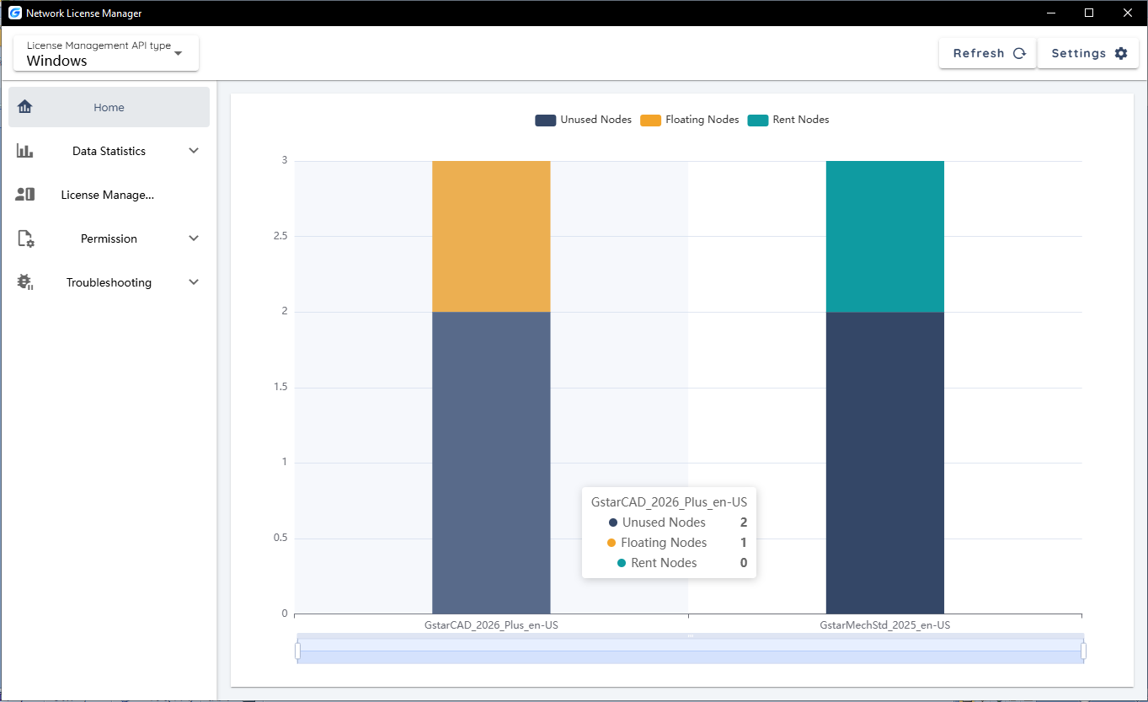

Authorization Data Statistics
On the Statistics page, you can view node activation (interval data), node usage (usage duration) and authorization failures (Activation failures) in a certain time period.

Interval Data Statistic
On the Statistics → Interval Data page, when multiple products are activated on the server at the same time, all data will be displayed in a table by default, which will make the data look confusing. In this case, you can use the product filter to select one or more products to view the data.

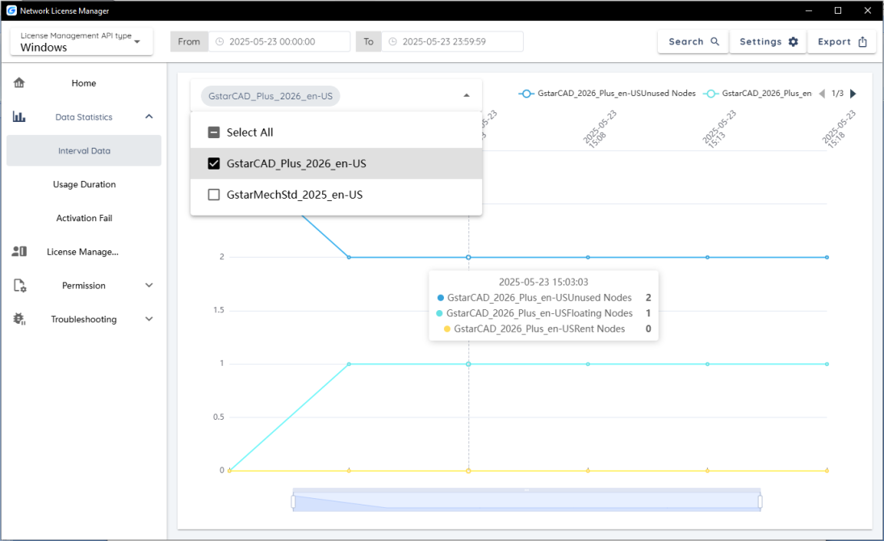

Usage Duration Statistic
The time when each user starts and closes the software will be recorded in Data Statistics → Usage Duration. This data can be used to view the time that users use CAD.
There are icons in the upper right corner. The Yellow data bar indicates that this user has obtained the authorization through renting, and the Blue data bar indicates that this user has obtained the authorization through floating. Detailed information will be displayed when the mouse is placed on the data bar.
You can also use the date or version filter to view the length of time users have used CAD within a certain period of time.
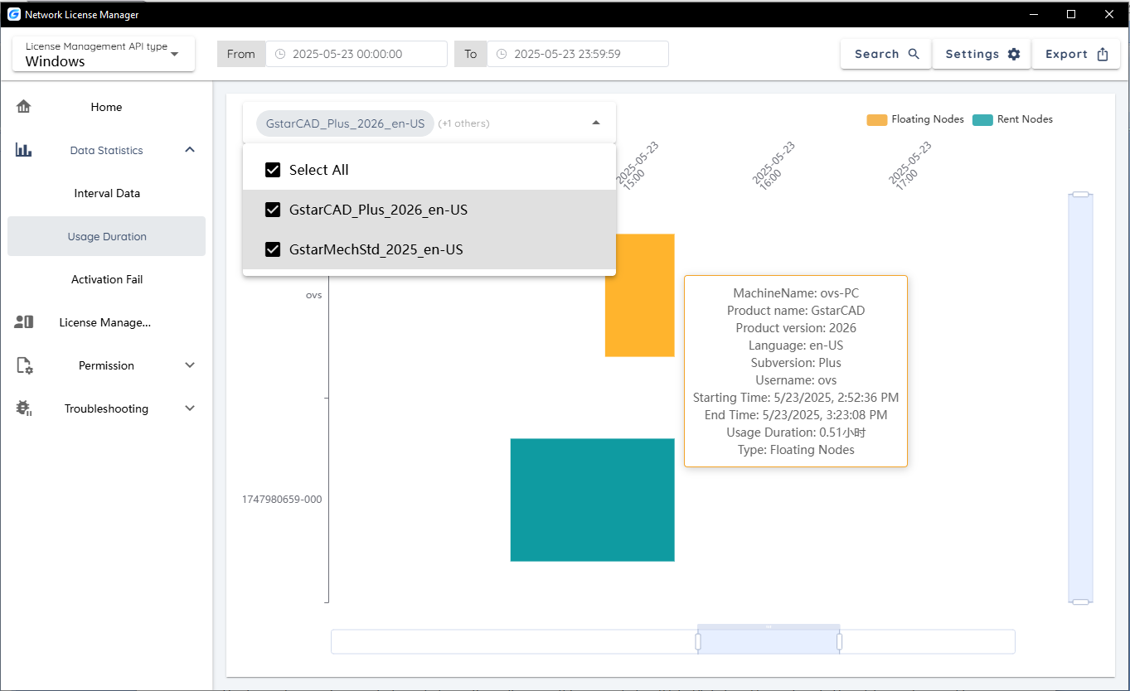

Activation Fail Statistic
In some cases, users may fail to obtain authorization from the server. There are many reasons for the failure, such as the nodes have been used up, blacklisted, etc. Through this page, the administrator can see the detailed reasons for the user's failure to obtain authorization, which is convenient for making the next decision.
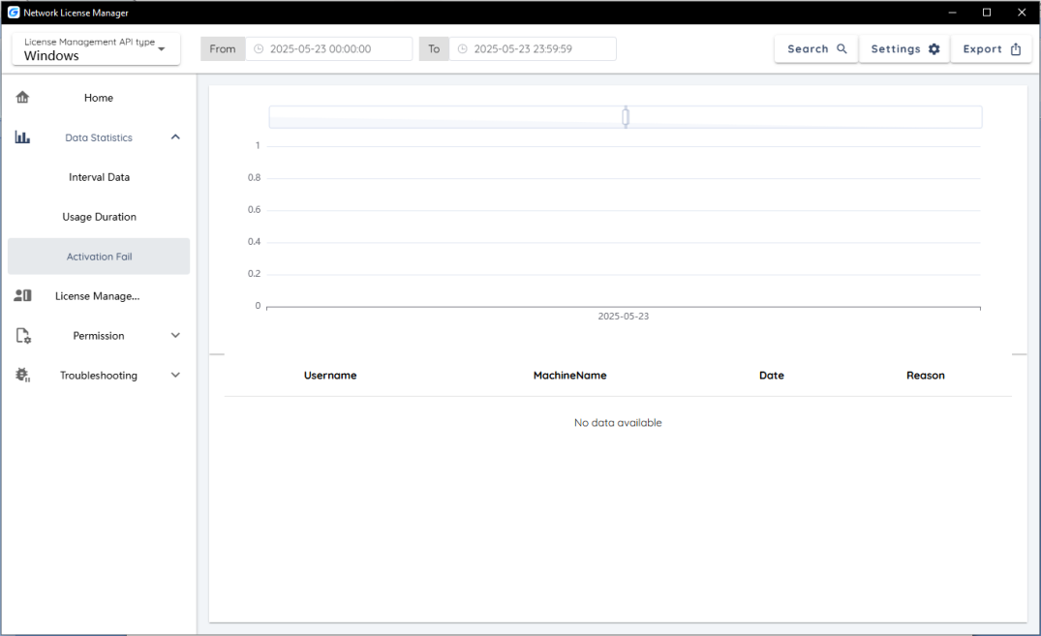

Authorization Data Export
In addition to visual data monitoring in the interface, the system also supports data export. The export button is provided in the upper right corner of the three interfaces mentioned above to support data export. Currently, only general export is provided which directly exports the data type of the relevant page. The exported data is relatively basic and requires some time to analyze the data.
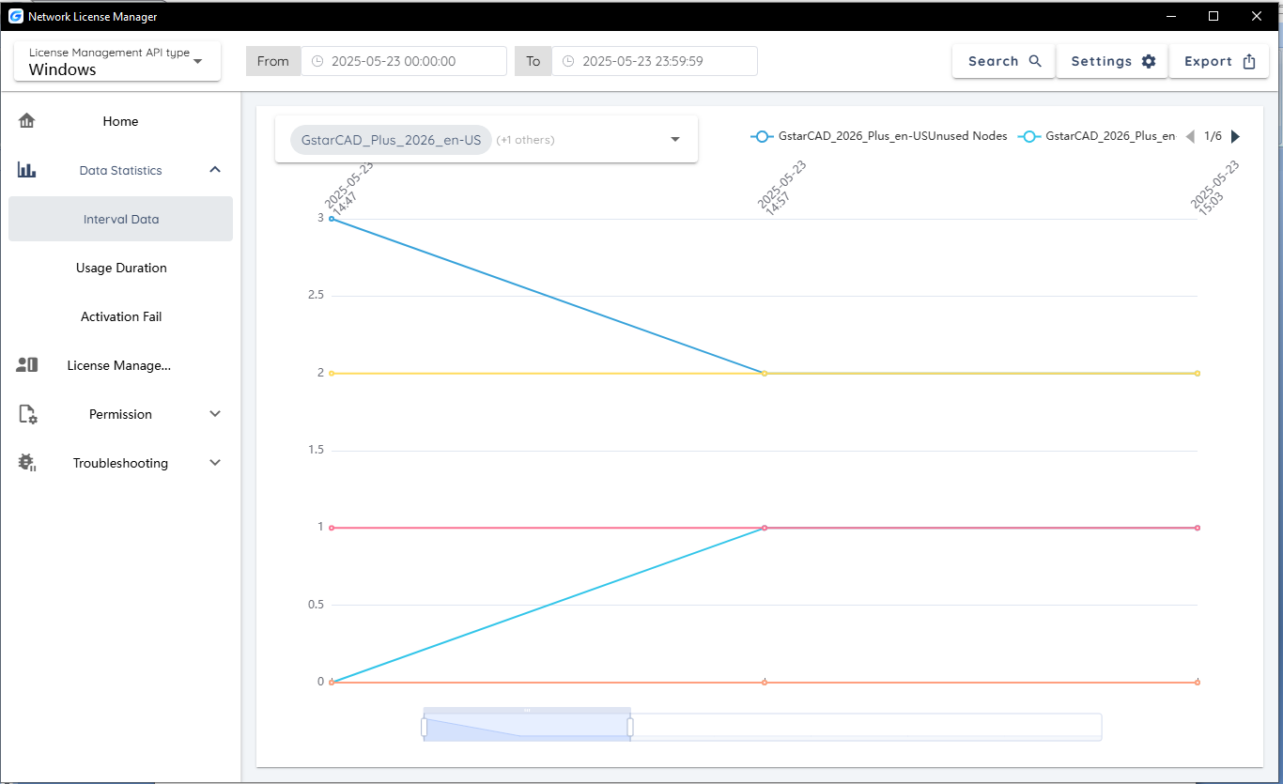

License Management
On this page, you can activate, return and repair authorization, and view other authorization information.
You can activate, return the GstarCAD network licenses online or manually, you can repair the license when it shows error message in license manager. The users whom are sharing your network license and lend detail also can be found in license manager.
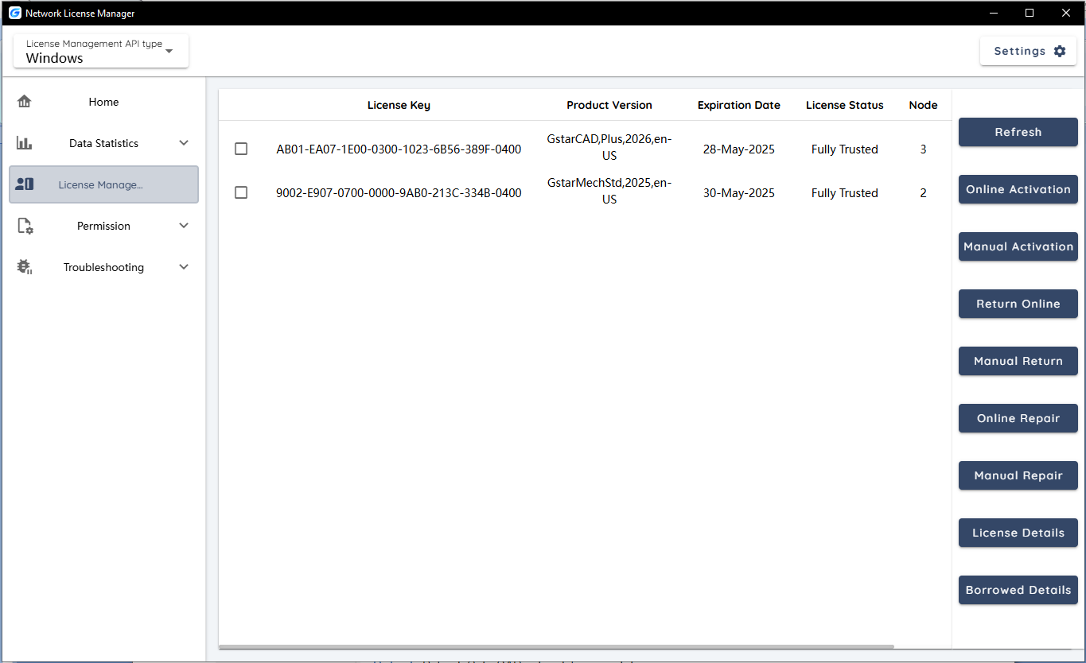

Feature list in License Manager:
Refresh: Refresh the GstarCAD network license status.
Online Activation: Activate the GstarCAD network license online. Ensure that your computer is connected to the Internet. After pasting or entering the license code, click 'OK' to activate the license.
Manual Activation: Manually activate the GstarCAD network license. If your computer cannot connect to the Internet, you can manually activate the network license by following the instructions.
Online Return: Return the GstarCAD network license online. Ensure your computer is connected to the Internet to return the license, and then you can use this network license to activate it on this or another machine.
Manual Return: Manually return the GstarCAD network license. If your computer cannot connect to the Internet, you can manually return the network license according to the operation prompts.
Online Repair: Repair the GstarCAD network license online. Ensure your computer is connected to the Internet. If there is an unexpected problem with the user's authorization, such as modifying the system time and other operations that cause the authorization to become invalid, you can try to repair it.
Manual Repair: Manually repair the GstarCAD network license. If your computer cannot connect to the Internet and the authorization fails unexpectedly, such as modifying the system time and other operations causing the authorization to become invalid, you can try to repair it.
License Details: Show detailed information about the licenses in use. Displays information about users who are connected to the server and occupying licenses, including user name, machine name, quantity, and time.
Borrowed Details: Show detailed information about the borrowed network licenses. Displays user information for those who borrow the network licenses, including the rental license ID, machine name, rental expiration date, etc.

Permission Settings (Optional)
To set user permissions, the fields in the User Information tab must be completed.

Enter the Authorization Number Information (Required)
Click Permission → User Information → Authorization Number, and click Add button to enter the license code. If the license code is entered incorrectly, you can modify it through the Edit button.
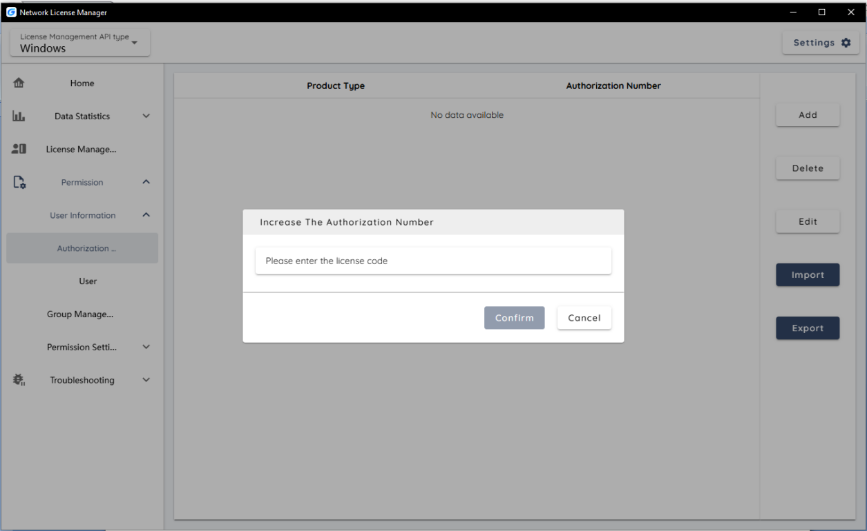

Add User Information (Required)
Click Permissions → User Information → User, and click Add to enter user information, including user name, host name, IP address. All users who need permission settings must have their information entered here.
Note: It is not mandatory to enter all items, but at least one item of information must be entered. It is recommended to fill in all the items.
This tool supports exporting the entered user information to ensure that the information can be reused. At the same time, the information can also be directly imported into the tool to avoid repeated data entry.

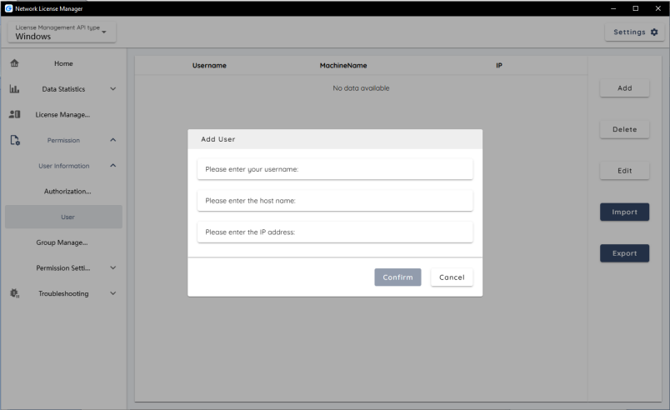

Create Multiple Users as a Group (Optional)
Click Group Management → Add button to create a named group for the specified users. After the group is created, it can be edited, including adding users to the group, removing users, etc. In this way, you can set permissions for users in the group in batches. This step can be performed according to actual conditions and is optional.
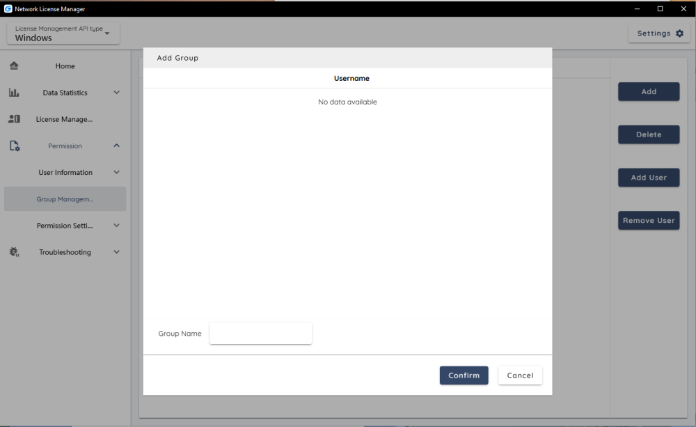

Permission Assignment
After adding the users' information, you can set permissions for the users. You can check/uncheck to allow/prohibit the user from obtaining authorization. After setting, click Apply and the permission setting will take effect.
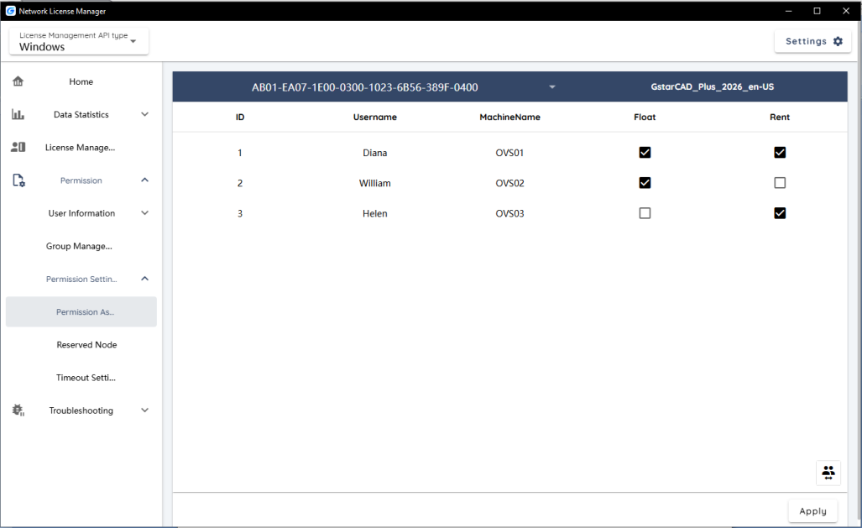

Reserved Nodes
In scenarios with tight authorization resources, when the quota for authorization nodes configured by the enterprise cannot meet usage demands, designers may be unable to obtain authorization, which can affect their work. GNLM's node reservation mechanism pre-allocates a specific number of authorization resources to core users or key user groups. This ensures that when system resources are overloaded, priority is given to personnel in important positions, allowing them to continue obtaining the authorization and maintain uninterrupted operation of design tasks.
Click Permission Settings → Reserved Nodes, you can select the product type, number of reserved nodes, and user information, and click the "Add" button to add the reserved information to the table.
If you need to set multiple reservation information, repeat the above steps. After the settings are completed, click Apply. When the "Read Successful" prompt appears at the top of the page, it means that the node reservation is successful.
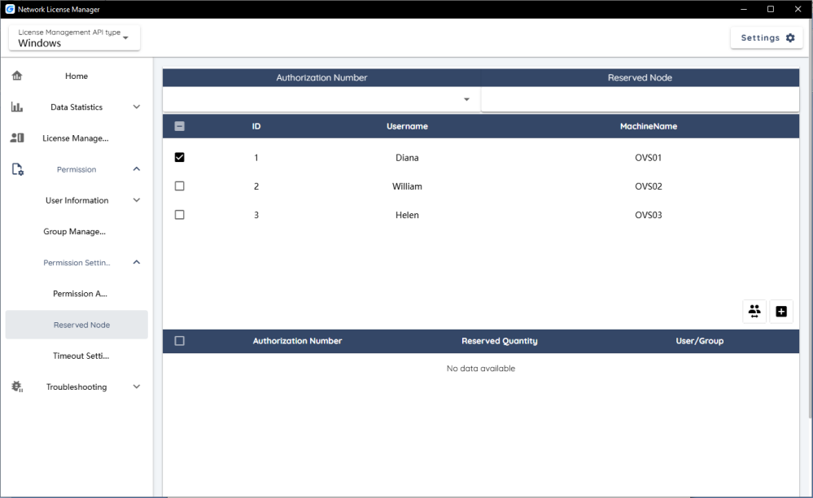

Timeout Settings
You can set the automatic release time of authorization. When the user does not use the software for a set period of time, the system will automatically reclaim the nodes occupied by the user. If the user does not run the product within the specified time, the user will be judged as an invalid user. The nodes of invalid users will be automatically revoked when there are insufficient nodes, and authorization resources will be allocated to active users first.
Note: You need to check "Enable timeout settings" to set the timeout period.
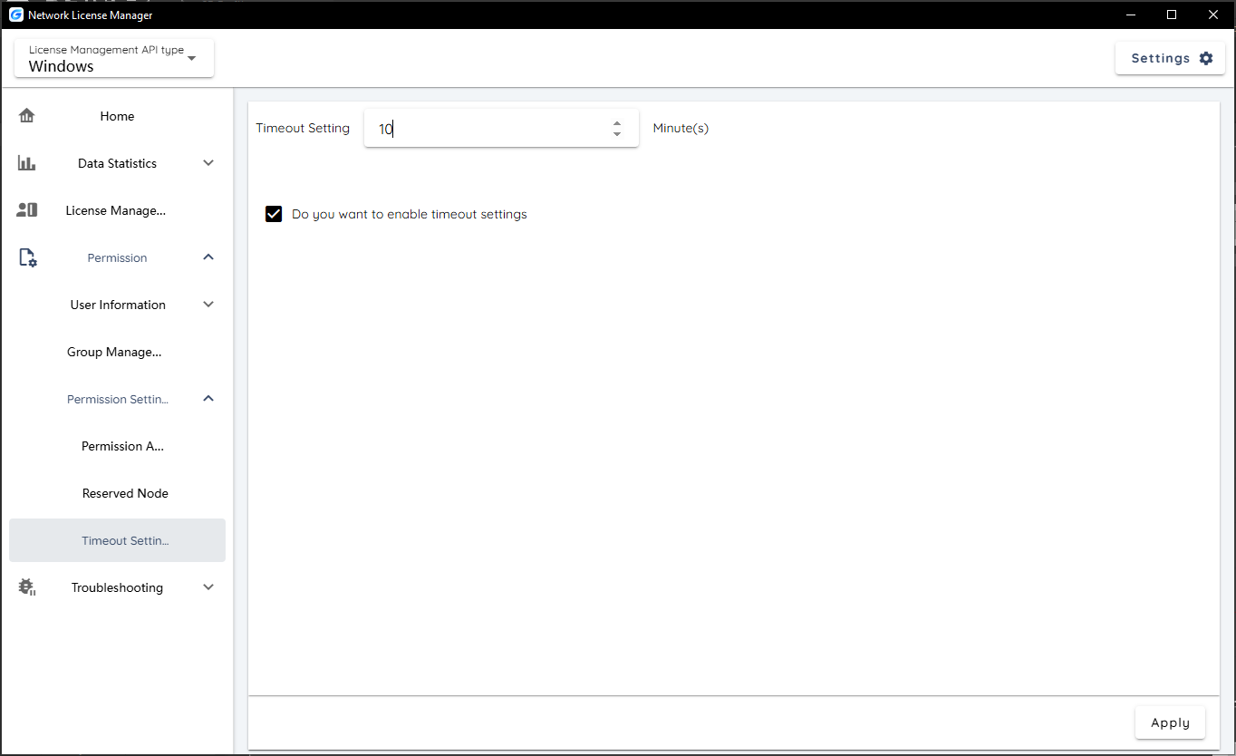

Troubleshooting
Trouble shooting is an automated inspection tool developed based on our experience in handling user authorization issues. It provides automated detection services. The system scans abnormal usage data and generates diagnostic suggestions to help you quickly locate the root cause of the problem.
Currently, three analysis methods are provided: Quick Diagnosis, Depth Diagnosis and Comprehensive Diagnosis, which can provide two analysis results: "The following users have lower versions occupying higher version authorizations" and "The following users occupy multiple nodes on one machine".
Note: In the future, as this tool version is updated, more analysis results will be provided to cover more usage scenarios.
Quick diagnosis: Troubleshoot problems by checking the current data on the server.
Depth diagnosis: Troubleshoot problems by checking historical data in the logs.
Comprehensive diagnosis: A combination of the above two diagnostic methods, involving a comprehensive analysis of data and troubleshooting.

Other Settings

Adjust Gstarsoft Network License Service
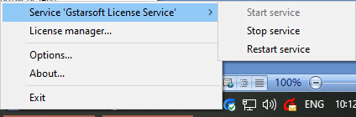

Start Service: Starts Gstarsoft License Service, other users whom with the permission can borrow or lend the licenses from the server.
Stop Service: Stop Gstarsoft License Service, other users whom with the permission will not allowed to borrow or lend the licenses from the server.
Restart Service: When the service meets some problems, you can try to restart it.
Note: If you need to do any changes on your license, please stop service first and restart service after the operation have been done.

GstarCAD Network License Service Version information
Get the Gstarsoft Network License Manager version information in About.
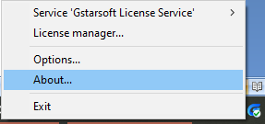

Quit GstarCAD Network License Manager
Click Exit to quit Gstarsoft Network License Manager tool.
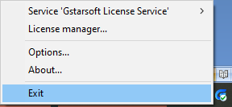

Uninstall
There are three ways to uninstall this tool.
Method 1: Through the system menu
Click Windows logo → All→ GNLM → right-click menu and uninstall, you can also search GNLM tool to uninstall it.

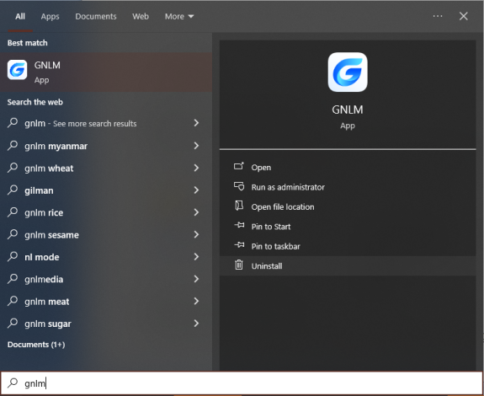

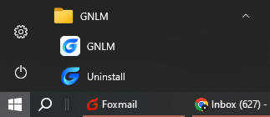

Method 2: Through the control panel
Click Control Panel → Uninstall a Program → GNLM, and click Uninstall/Change.
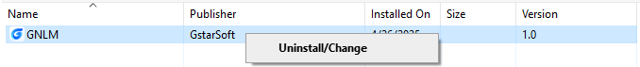

Method 3: Uninstall from the program
Enter the GNLM installation directory, and double click Uninstall.exe to run it. Then follow the prompts to complete uninstall of this tool.
